CHAPTER SEVEN
RESULTS AND VALIDATION ASSESSMENT
Evaluation and Deployment of 3D-Printed Automatic Weather Stations (3D-PAWS) in Kenya with Integrated Data Visualization and Monitoring Systems
Station: KITALE - NEW
KMD Reference Station: KITALE METEOROLOGICAL STATION - NEW
Validation Period: 2024-10_to_2026-07

This chapter presents the results of the comparative validation assessment between the 3D-PAWS station observations and corresponding Kenya Meteorological Department (KMD) reference observations. The assessment evaluates the performance of temperature, relative humidity, atmospheric pressure, and rainfall observations using statistical analysis, quality assessment, and graphical comparison methods implemented within the 3D-PAWS Validation Toolkit.

7.1 Overview of the Results
The validation assessment was conducted for KITALE - NEW using KITALE METEOROLOGICAL STATION - NEW as the Kenya Meteorological Department (KMD) reference station. The evaluation period extended from 2024-10-11 to 2026-07-30, representing a validation period of 658 days.
The assessment evaluated the performance of 3D-PAWS observations against KMD reference measurements for key meteorological variables including temperature, relative humidity, atmospheric pressure, and rainfall. The validation process included dataset standardization, observation-period alignment, quality assessment, statistical evaluation, and graphical comparison using the developed 3D-PAWS Validation Toolkit.
The analysis generated 11 parameter-level validation results. 11 parameters received formal performance assessments based on statistical criteria, while 0 parameters were not formally assessed due to limitations related to data availability, quality control filtering, or insufficient paired observations.
The results presented in this chapter provide an evaluation of the suitability of locally fabricated 3D-PAWS systems for meteorological observation network densification and support the assessment of their potential for operational deployment.
3D-PAWS Station | KITALE - NEW
KMD Reference Station | KITALE METEOROLOGICAL STATION - NEW
Validation Period | 2024-10_to_2026-07
Observation Start | 2024-10-11
Observation End | 2026-07-30
Validation Days | 658
Parameters Evaluated | 11
Parameters Assessed | 11
Parameters Not Assessed | 0

7.2 Dataset Availability, Completeness and Quality Assessment
This section presents the availability, completeness, and quality assessment of observations used for the validation exercise. Sensor-level quality information from the 3D-PAWS system is presented separately from daily validation coverage used for comparison with the Kenya Meteorological Department (KMD) reference dataset.

7.2.1 3D-PAWS Sensor Data Quality Assessment
Parameter | Sensor | Observations | Valid | Validity (%) | QC Flags | Missing | Quality Level
Temperature | mt1 | 24863 | 24857 | 99.98% | 6 | 0 | HIGH QUALITY
Humidity | sh1 | 24863 | 24857 | 99.98% | 6 | 0 | HIGH QUALITY
Pressure | bp1 | 24863 | 24847 | 99.94% | 16 | 0 | HIGH QUALITY
Sensor-level quality control was performed using the variable-specific validation rules implemented in the 3D-PAWS Validation Toolkit. Valid observations were retained for statistical evaluation, while quality-flagged observations were identified and handled separately. For rainfall variables, zero observations were retained as valid measurements because they represent actual dry conditions rather than missing data.

7.2.2 Daily Validation Coverage
Parameter | Paired Days | Missing Days | Coverage (%)
Maximum Temperature | 152 | 506 | 23.1%
Minimum Temperature | 147 | 511 | 22.3%
Mean Temperature | 143 | 515 | 21.7%
Maximum Relative Humidity | 146 | 512 | 22.2%
Minimum Relative Humidity | 146 | 512 | 22.2%
Mean Relative Humidity | 146 | 512 | 22.2%
Maximum Pressure | 146 | 512 | 22.2%
Minimum Pressure | 146 | 512 | 22.2%
Mean Pressure | 146 | 512 | 22.2%
Daily Rainfall (Rain Gauge 1) | 166 | 492 | 25.2%
Daily Rainfall (Rain Gauge 2) | 166 | 492 | 25.2%
Daily validation coverage represents the proportion of observations where 3D-PAWS and KMD measurements were available for direct comparison. Differences in coverage may result from data availability, quality-control filtering, and differences in daily record completeness. Statistical performance metrics were calculated only using paired observations within the common validation period.
The validation assessment included 11 meteorological parameters. Parameter-specific coverage values were considered during interpretation to ensure that reported statistics represent available paired observations.

7.3 Validation Statistics and Performance Assessment
The validation assessment compares paired 3D-PAWS and Kenya Meteorological Department (KMD) observations within the common validation period. Statistical performance metrics were calculated using observations available from both systems after the applicable quality-control and data-availability procedures.

7.3.1 Statistical Performance Indicators
The comparison uses several complementary statistical indicators to evaluate agreement between 3D-PAWS and KMD observations. Bias indicates the mean systematic difference between the two observation systems. Mean Absolute Error (MAE) represents the average magnitude of the absolute differences, while Root Mean Square Error (RMSE) gives greater weight to larger differences.
The correlation coefficient (r) is used to evaluate the strength of the linear temporal relationship between 3D-PAWS and KMD observations. The coefficient of determination (R²) indicates the proportion of variance in the KMD observations that is explained by the corresponding 3D-PAWS observations.

7.3.2 Performance Classification
Performance classification was based on the parameter-specific criteria implemented in the 3D-PAWS Validation Toolkit. Where WMO requirement criteria were available, the assessment considers the Goal, Breakthrough, and Threshold levels associated with the relevant meteorological parameter.
A parameter classified as Threshold met the implemented Threshold criterion for the corresponding performance measure. Parameters classified as Below Threshold did not meet the implemented Threshold criterion. Such classification is interpreted together with correlation, bias, MAE, RMSE, observation coverage, and the intended operational application of the parameter.

7.3.3 Interpretation of Statistical Agreement
Statistical indicators are interpreted collectively rather than using a single metric in isolation. Strong correlation indicates that the 3D-PAWS system follows the temporal variability observed by the KMD reference system, while bias and error statistics indicate the degree of numerical agreement between the two datasets.
Differences between the two observation systems may also reflect sensor characteristics, calibration, station exposure, elevation effects, precipitation spatial variability, and differences in measurement procedures. Consequently, statistical classifications are considered together with the physical and operational characteristics of each parameter.

7.4 Temperature Results

Maximum Temperature
Data status: HIGH QUALITY | Paired observations: 152 | Comparison missing: 506 | Faulty observations: 6
Descriptive statistics
Statistic | 3DPAWS | KMD
Observations | 152 | 152
Mean | 28.019 | 27.667
Median | 27.890 | 27.400
Minimum | 14.620 | 18.450
Maximum | 33.690 | 33.100
Standard Deviation | 2.782 | 2.280
Variance | 7.739 | 5.197
Validation statistics
Metric | Value
Bias | 0.352 °C
Mean Absolute Error (MAE) | 1.214 °C
Root Mean Square Error (RMSE) | 2.282 °C
Correlation coefficient (r) | 0.616
Coefficient of determination (R²) | 0.380
Performance assessment: Below Threshold
WMO requirement: 253
Criterion | Value
Goal | 0.500 °C
Breakthrough | 1.000 °C
Threshold | 2.000 °C
Interpretation: The paired observations show moderate linear agreement between 3DPAWS and KMD measurements (r = 0.616). The coefficient of determination was R² = 0.380. The mean bias was 0.352 °C, indicating that the 3DPAWS observations were generally higher than the KMD observations. The mean absolute error was 1.214 °C. The root mean square error was 2.282 °C. Under the implemented performance assessment criteria, the parameter was classified as Below Threshold.
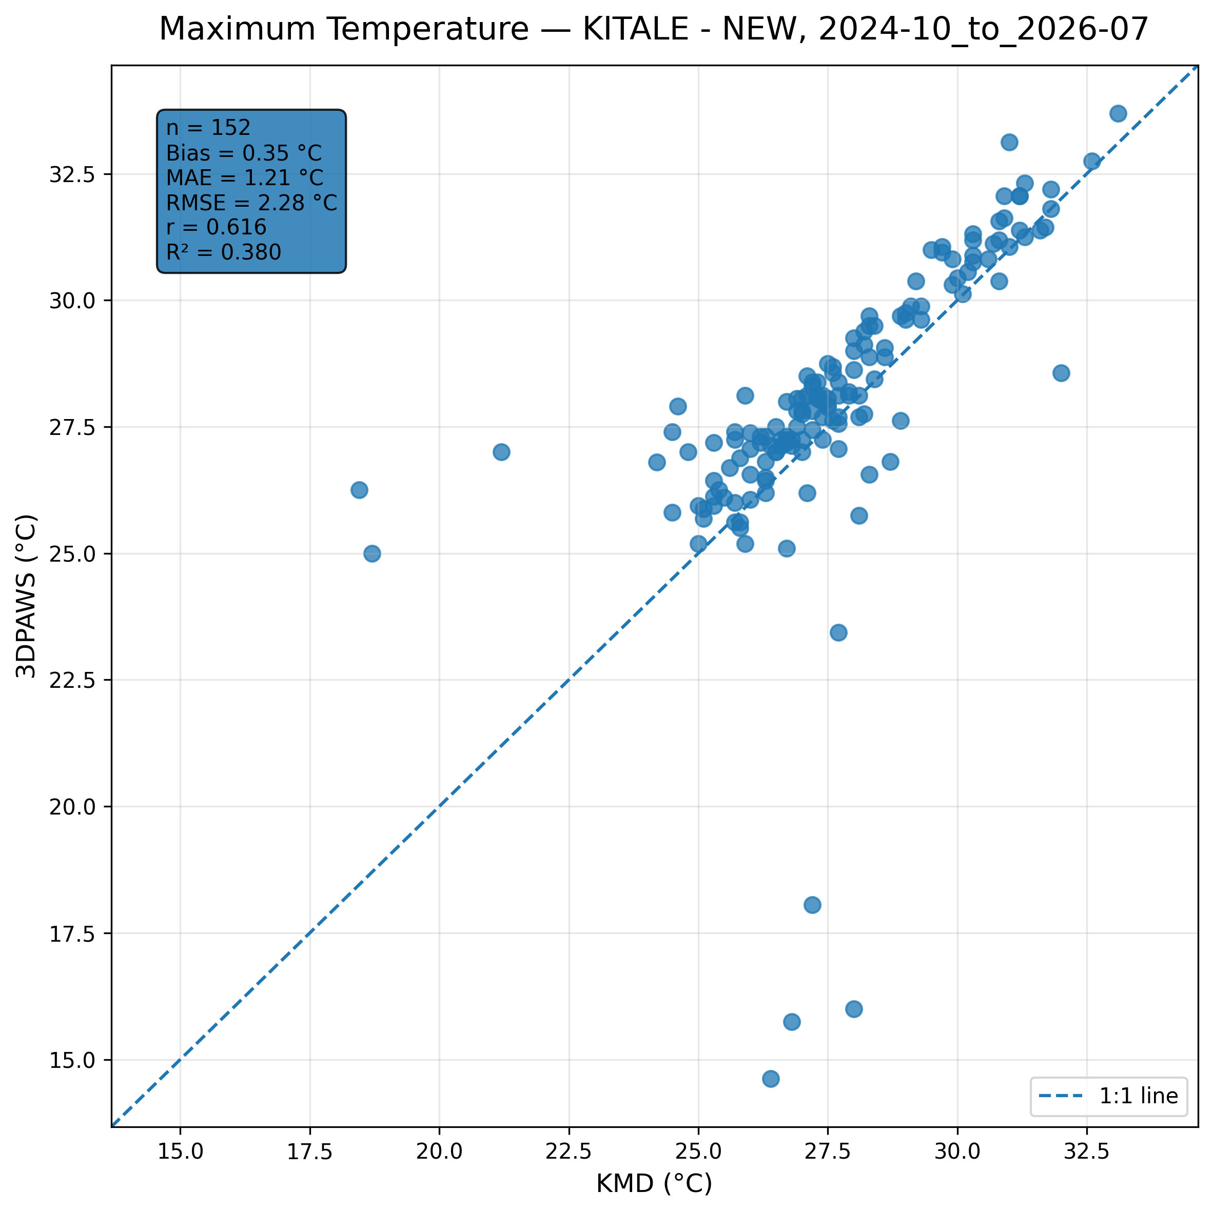
Figure 7.1: Scatter comparison of maximum temperature observations between 3DPAWS and KMD at KITALE - NEW for 2024-10_to_2026-07.
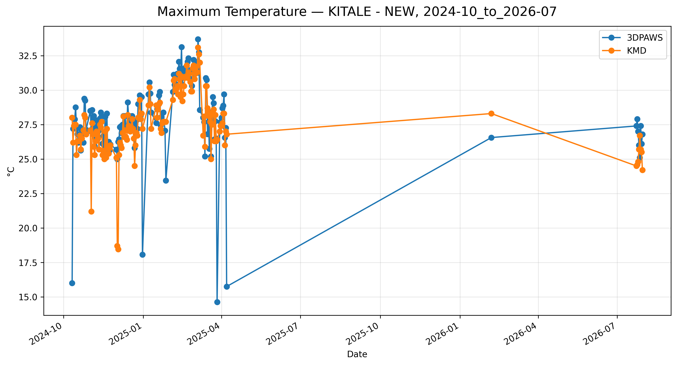
Figure 7.2: Time-series comparison of daily maximum temperature observations between 3DPAWS and KMD at KITALE - NEW for 2024-10_to_2026-07.

Minimum Temperature
Data status: HIGH QUALITY | Paired observations: 147 | Comparison missing: 511 | Faulty observations: 6
Descriptive statistics
Statistic | 3DPAWS | KMD
Observations | 147 | 147
Mean | 12.878 | 13.080
Median | 12.560 | 13.000
Minimum | 8.560 | 9.500
Maximum | 26.560 | 21.100
Standard Deviation | 2.672 | 1.949
Variance | 7.138 | 3.797
Validation statistics
Metric | Value
Bias | -0.202 °C
Mean Absolute Error (MAE) | 1.289 °C
Root Mean Square Error (RMSE) | 2.369 °C
Correlation coefficient (r) | 0.512
Coefficient of determination (R²) | 0.262
Performance assessment: Below Threshold
WMO requirement: 253
Criterion | Value
Goal | 0.500 °C
Breakthrough | 1.000 °C
Threshold | 2.000 °C
Interpretation: The paired observations show moderate linear agreement between 3DPAWS and KMD measurements (r = 0.512). The coefficient of determination was R² = 0.262. The mean bias was -0.202 °C, indicating that the 3DPAWS observations were generally lower than the KMD observations. The mean absolute error was 1.289 °C. The root mean square error was 2.369 °C. Under the implemented performance assessment criteria, the parameter was classified as Below Threshold.
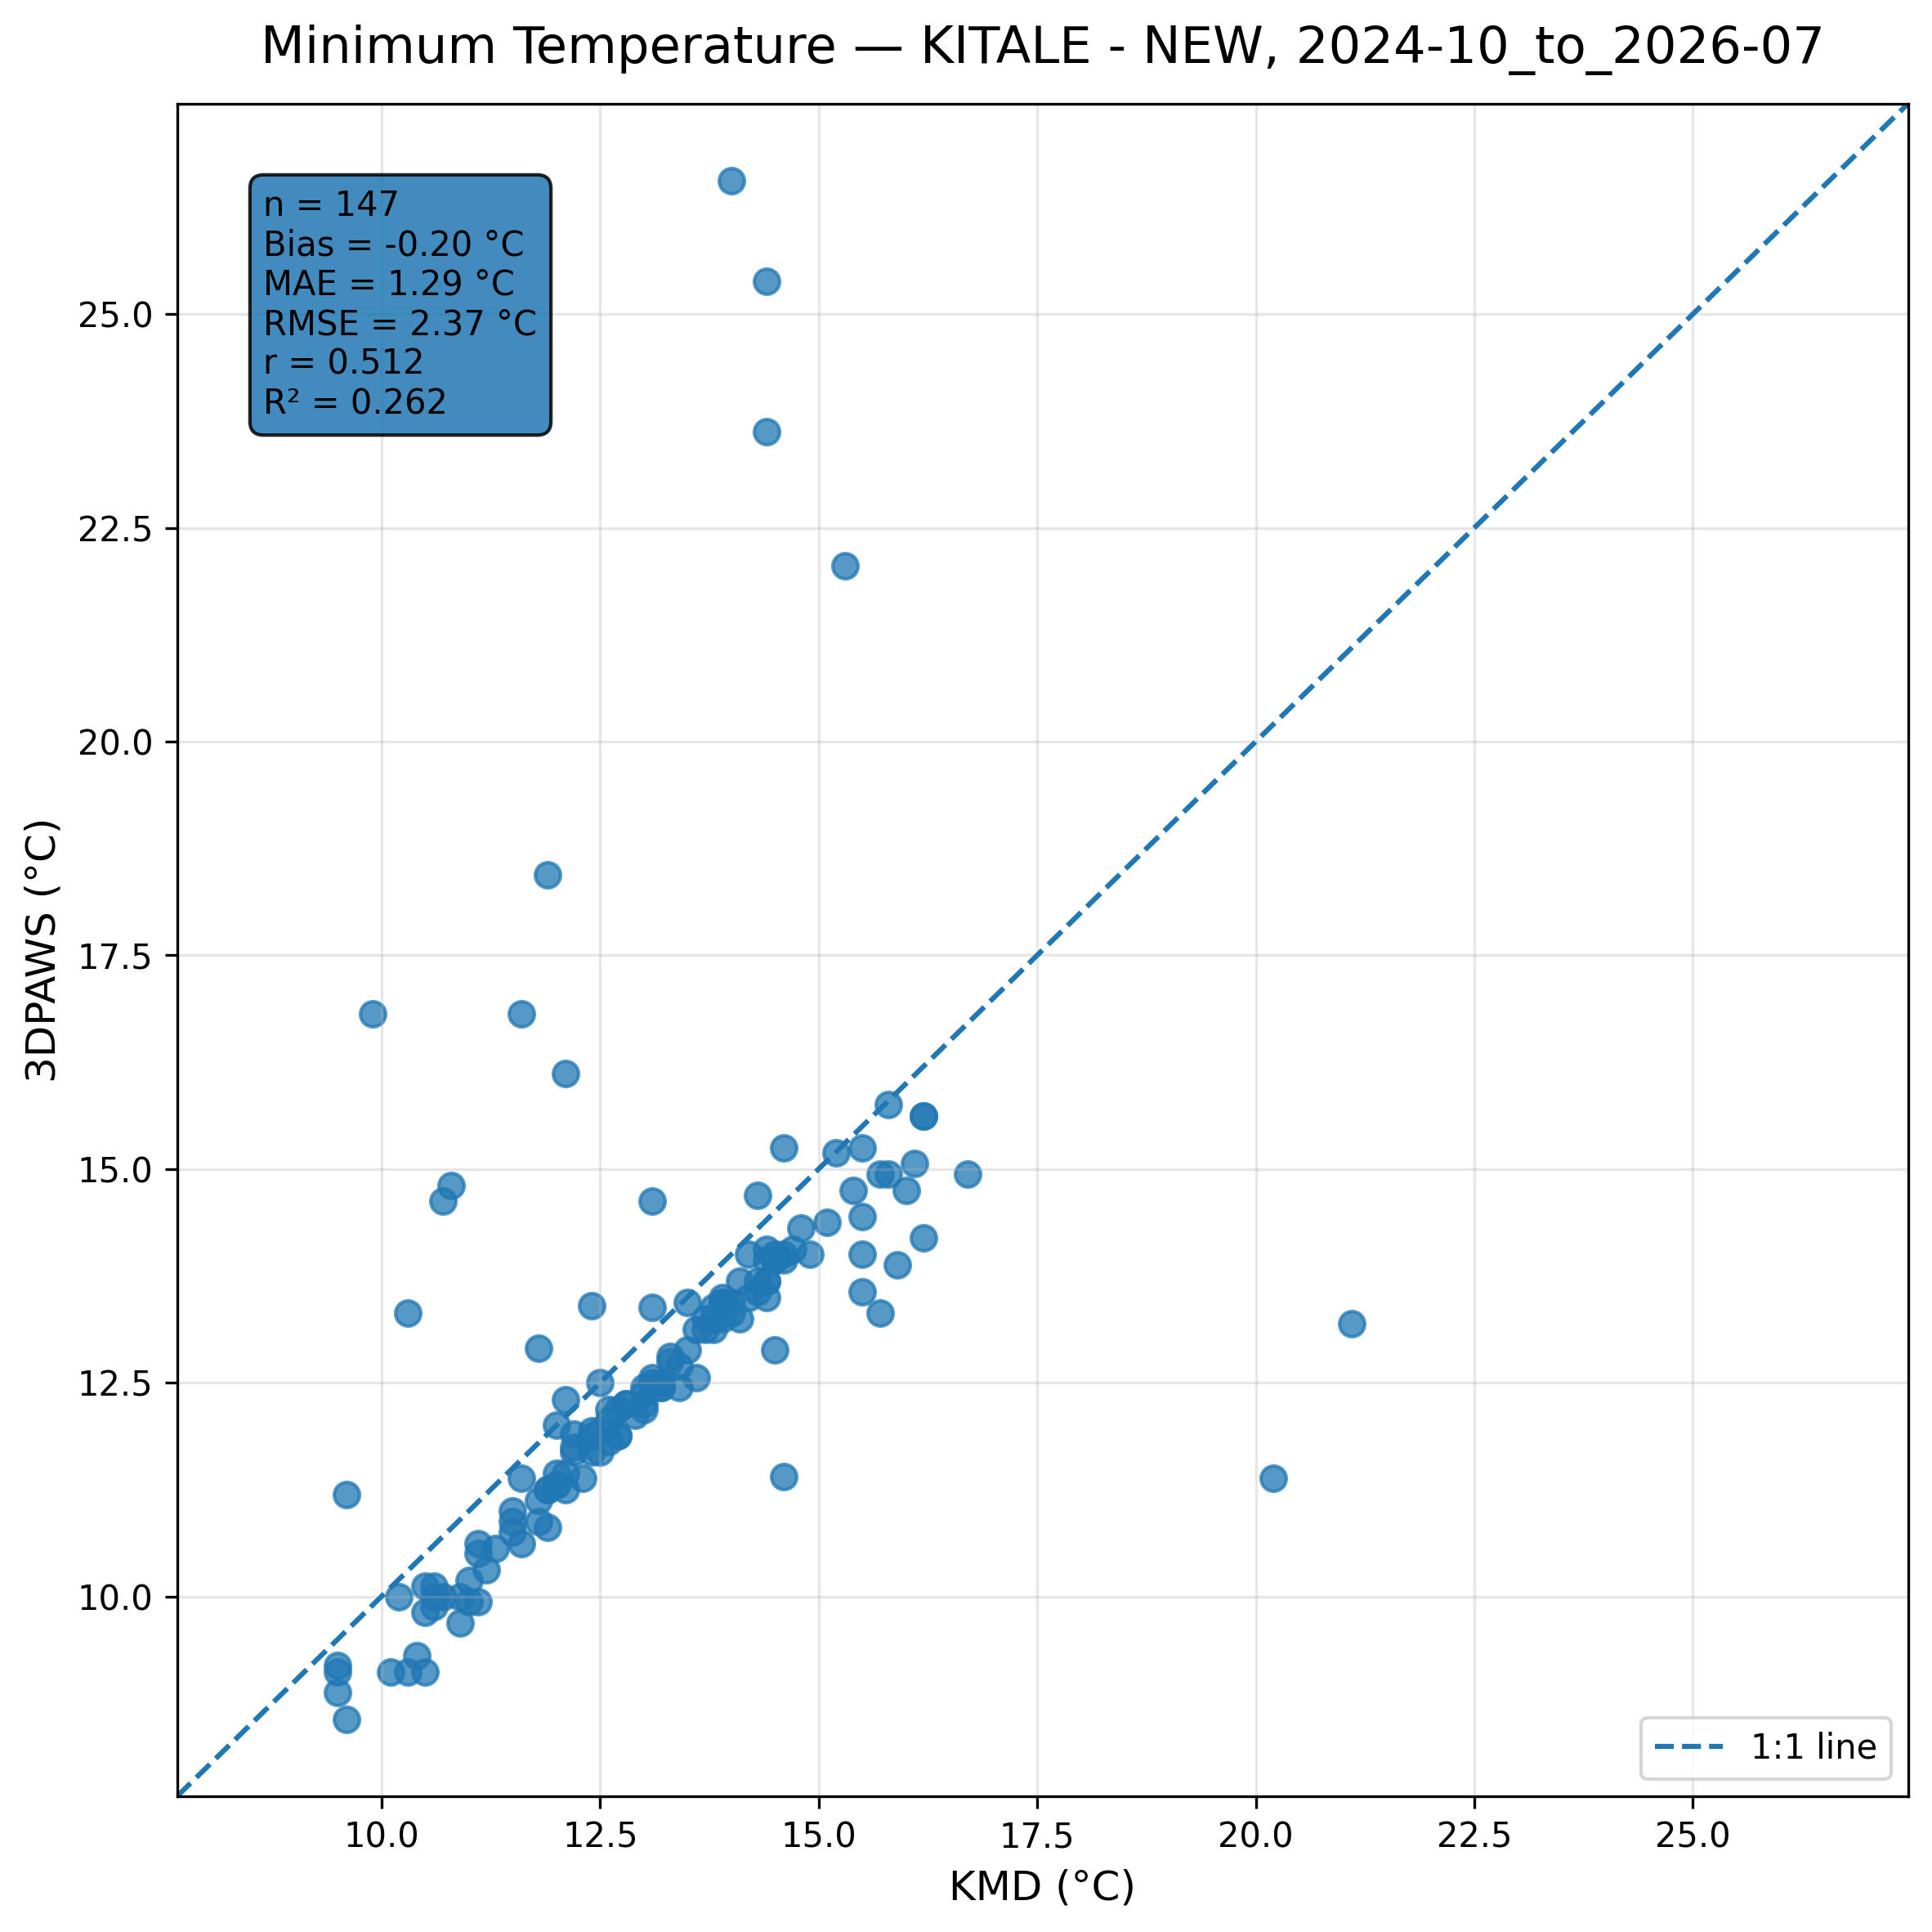
Figure 7.3: Scatter comparison of minimum temperature observations between 3DPAWS and KMD at KITALE - NEW for 2024-10_to_2026-07.
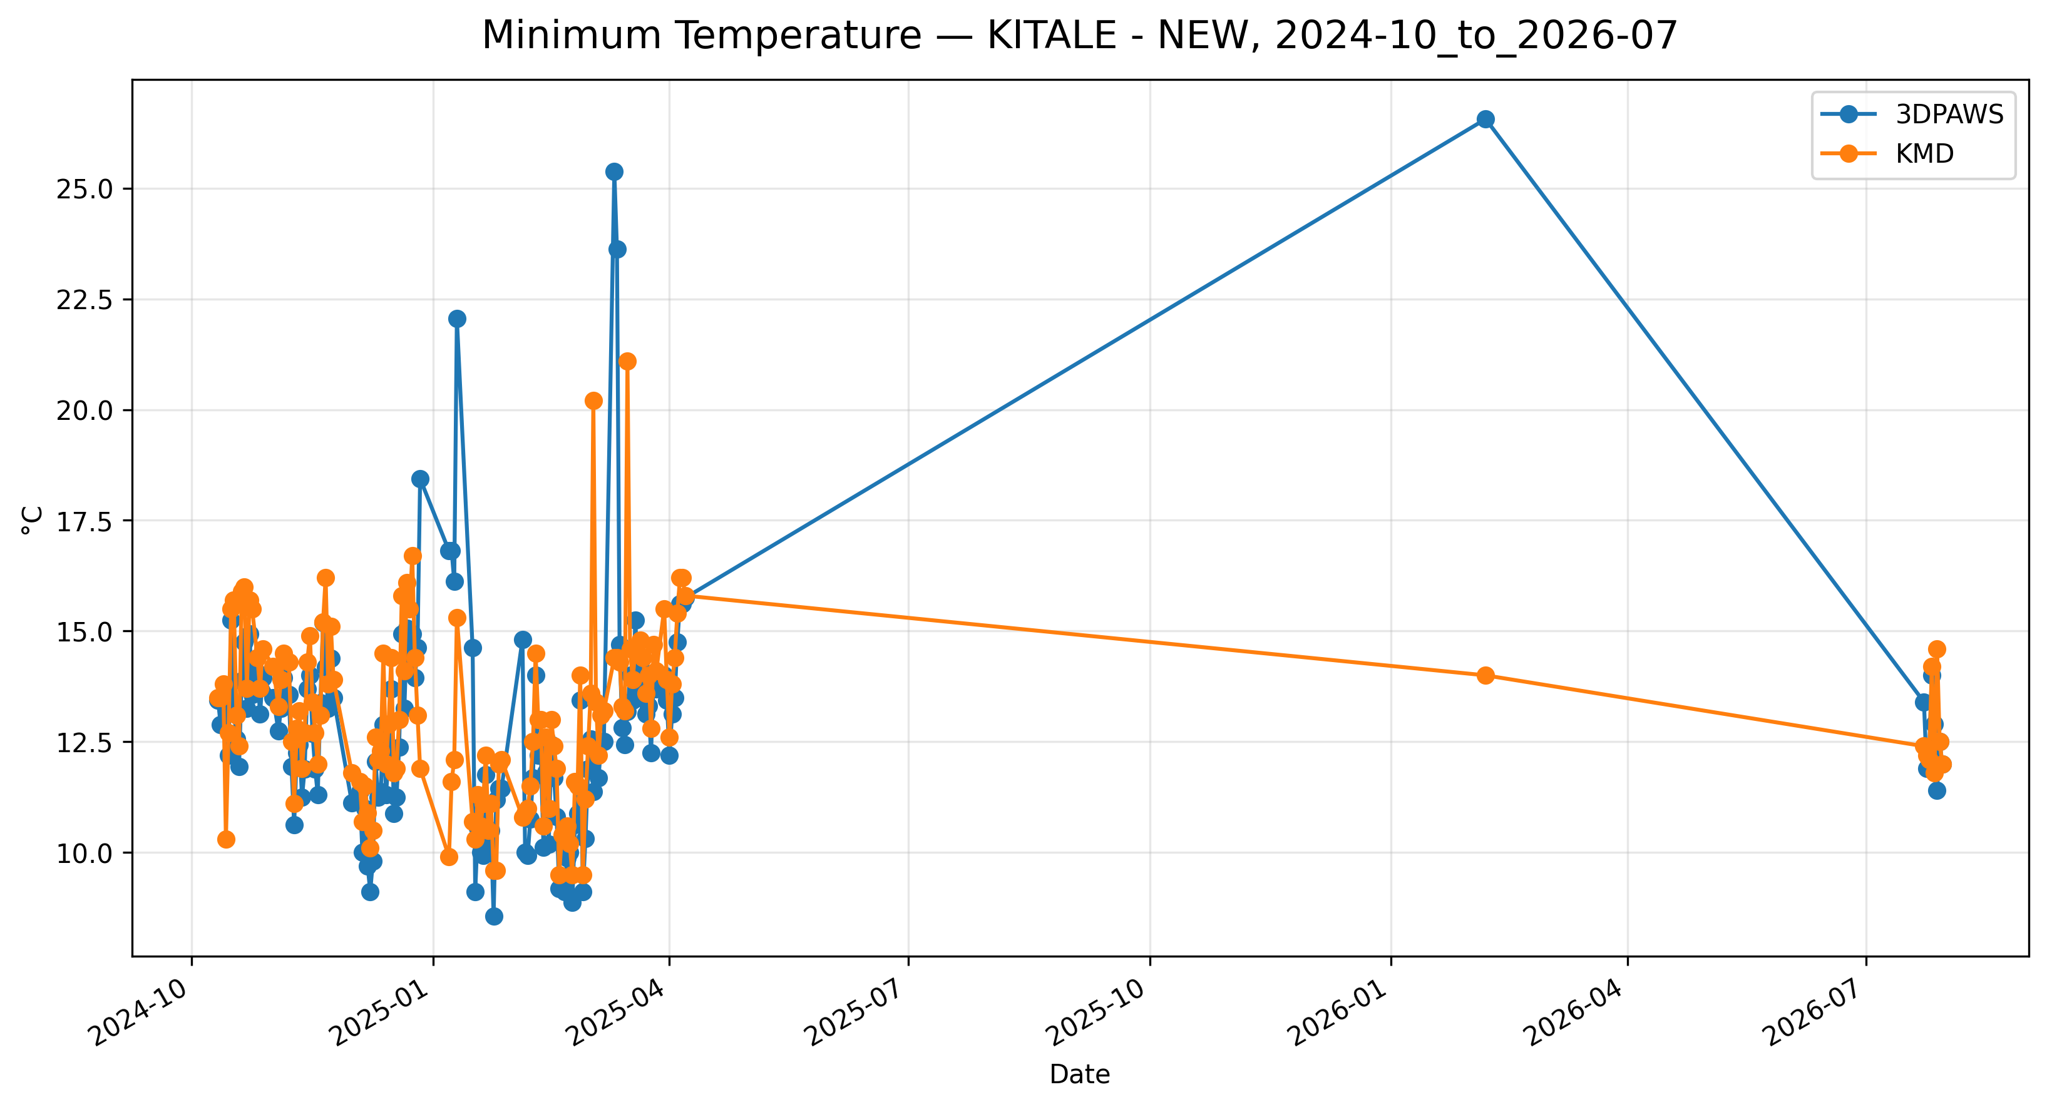
Figure 7.4: Time-series comparison of daily minimum temperature observations between 3DPAWS and KMD at KITALE - NEW for 2024-10_to_2026-07.

Mean Temperature
Data status: HIGH QUALITY | Paired observations: 143 | Comparison missing: 515 | Faulty observations: 6
Descriptive statistics
Statistic | 3DPAWS | KMD
Observations | 143 | 143
Mean | 19.514 | 20.451
Median | 19.196 | 20.450
Minimum | 14.113 | 18.100
Maximum | 26.826 | 25.950
Standard Deviation | 1.966 | 1.172
Variance | 3.865 | 1.375
Validation statistics
Metric | Value
Bias | -0.937 °C
Mean Absolute Error (MAE) | 1.445 °C
Root Mean Square Error (RMSE) | 2.085 °C
Correlation coefficient (r) | 0.379
Coefficient of determination (R²) | 0.143
Performance assessment: Below Threshold
WMO requirement: 253
Criterion | Value
Goal | 0.500 °C
Breakthrough | 1.000 °C
Threshold | 2.000 °C
Interpretation: The paired observations show weak linear agreement between 3DPAWS and KMD measurements (r = 0.379). The coefficient of determination was R² = 0.143. The mean bias was -0.937 °C, indicating that the 3DPAWS observations were generally lower than the KMD observations. The mean absolute error was 1.445 °C. The root mean square error was 2.085 °C. Under the implemented performance assessment criteria, the parameter was classified as Below Threshold.
Figure 7.5: Scatter comparison of mean temperature observations between 3DPAWS and KMD at KITALE - NEW for 2024-10_to_2026-07.
Figure 7.6: Time-series comparison of daily mean temperature observations between 3DPAWS and KMD at KITALE - NEW for 2024-10_to_2026-07.

7.5 Relative Humidity Results

Maximum Relative Humidity
Data status: HIGH QUALITY | Paired observations: 146 | Comparison missing: 512 | Faulty observations: 6
Descriptive statistics
Statistic | 3DPAWS | KMD
Observations | 146 | 146
Mean | 89.030 | 63.737
Median | 94.365 | 67.220
Minimum | 46.720 | 26.160
Maximum | 97.700 | 94.870
Standard Deviation | 10.754 | 14.483
Variance | 115.643 | 209.758
Validation statistics
Metric | Value
Bias | 25.293 %
Mean Absolute Error (MAE) | 26.398 %
Root Mean Square Error (RMSE) | 28.177 %
Correlation coefficient (r) | 0.546
Coefficient of determination (R²) | 0.298
Performance assessment: Below Threshold
WMO requirement: 776
Criterion | Value
Goal | 0.500 %
Breakthrough | 2.500 %
Threshold | 5.000 %
Interpretation: The paired observations show moderate linear agreement between 3DPAWS and KMD measurements (r = 0.546). The coefficient of determination was R² = 0.298. The mean bias was 25.293 %, indicating that the 3DPAWS observations were generally higher than the KMD observations. The mean absolute error was 26.398 %. The root mean square error was 28.177 %. Under the implemented performance assessment criteria, the parameter was classified as Below Threshold. The relatively high correlation indicates that 3D-PAWS successfully captured temporal humidity variability despite differences in absolute values.
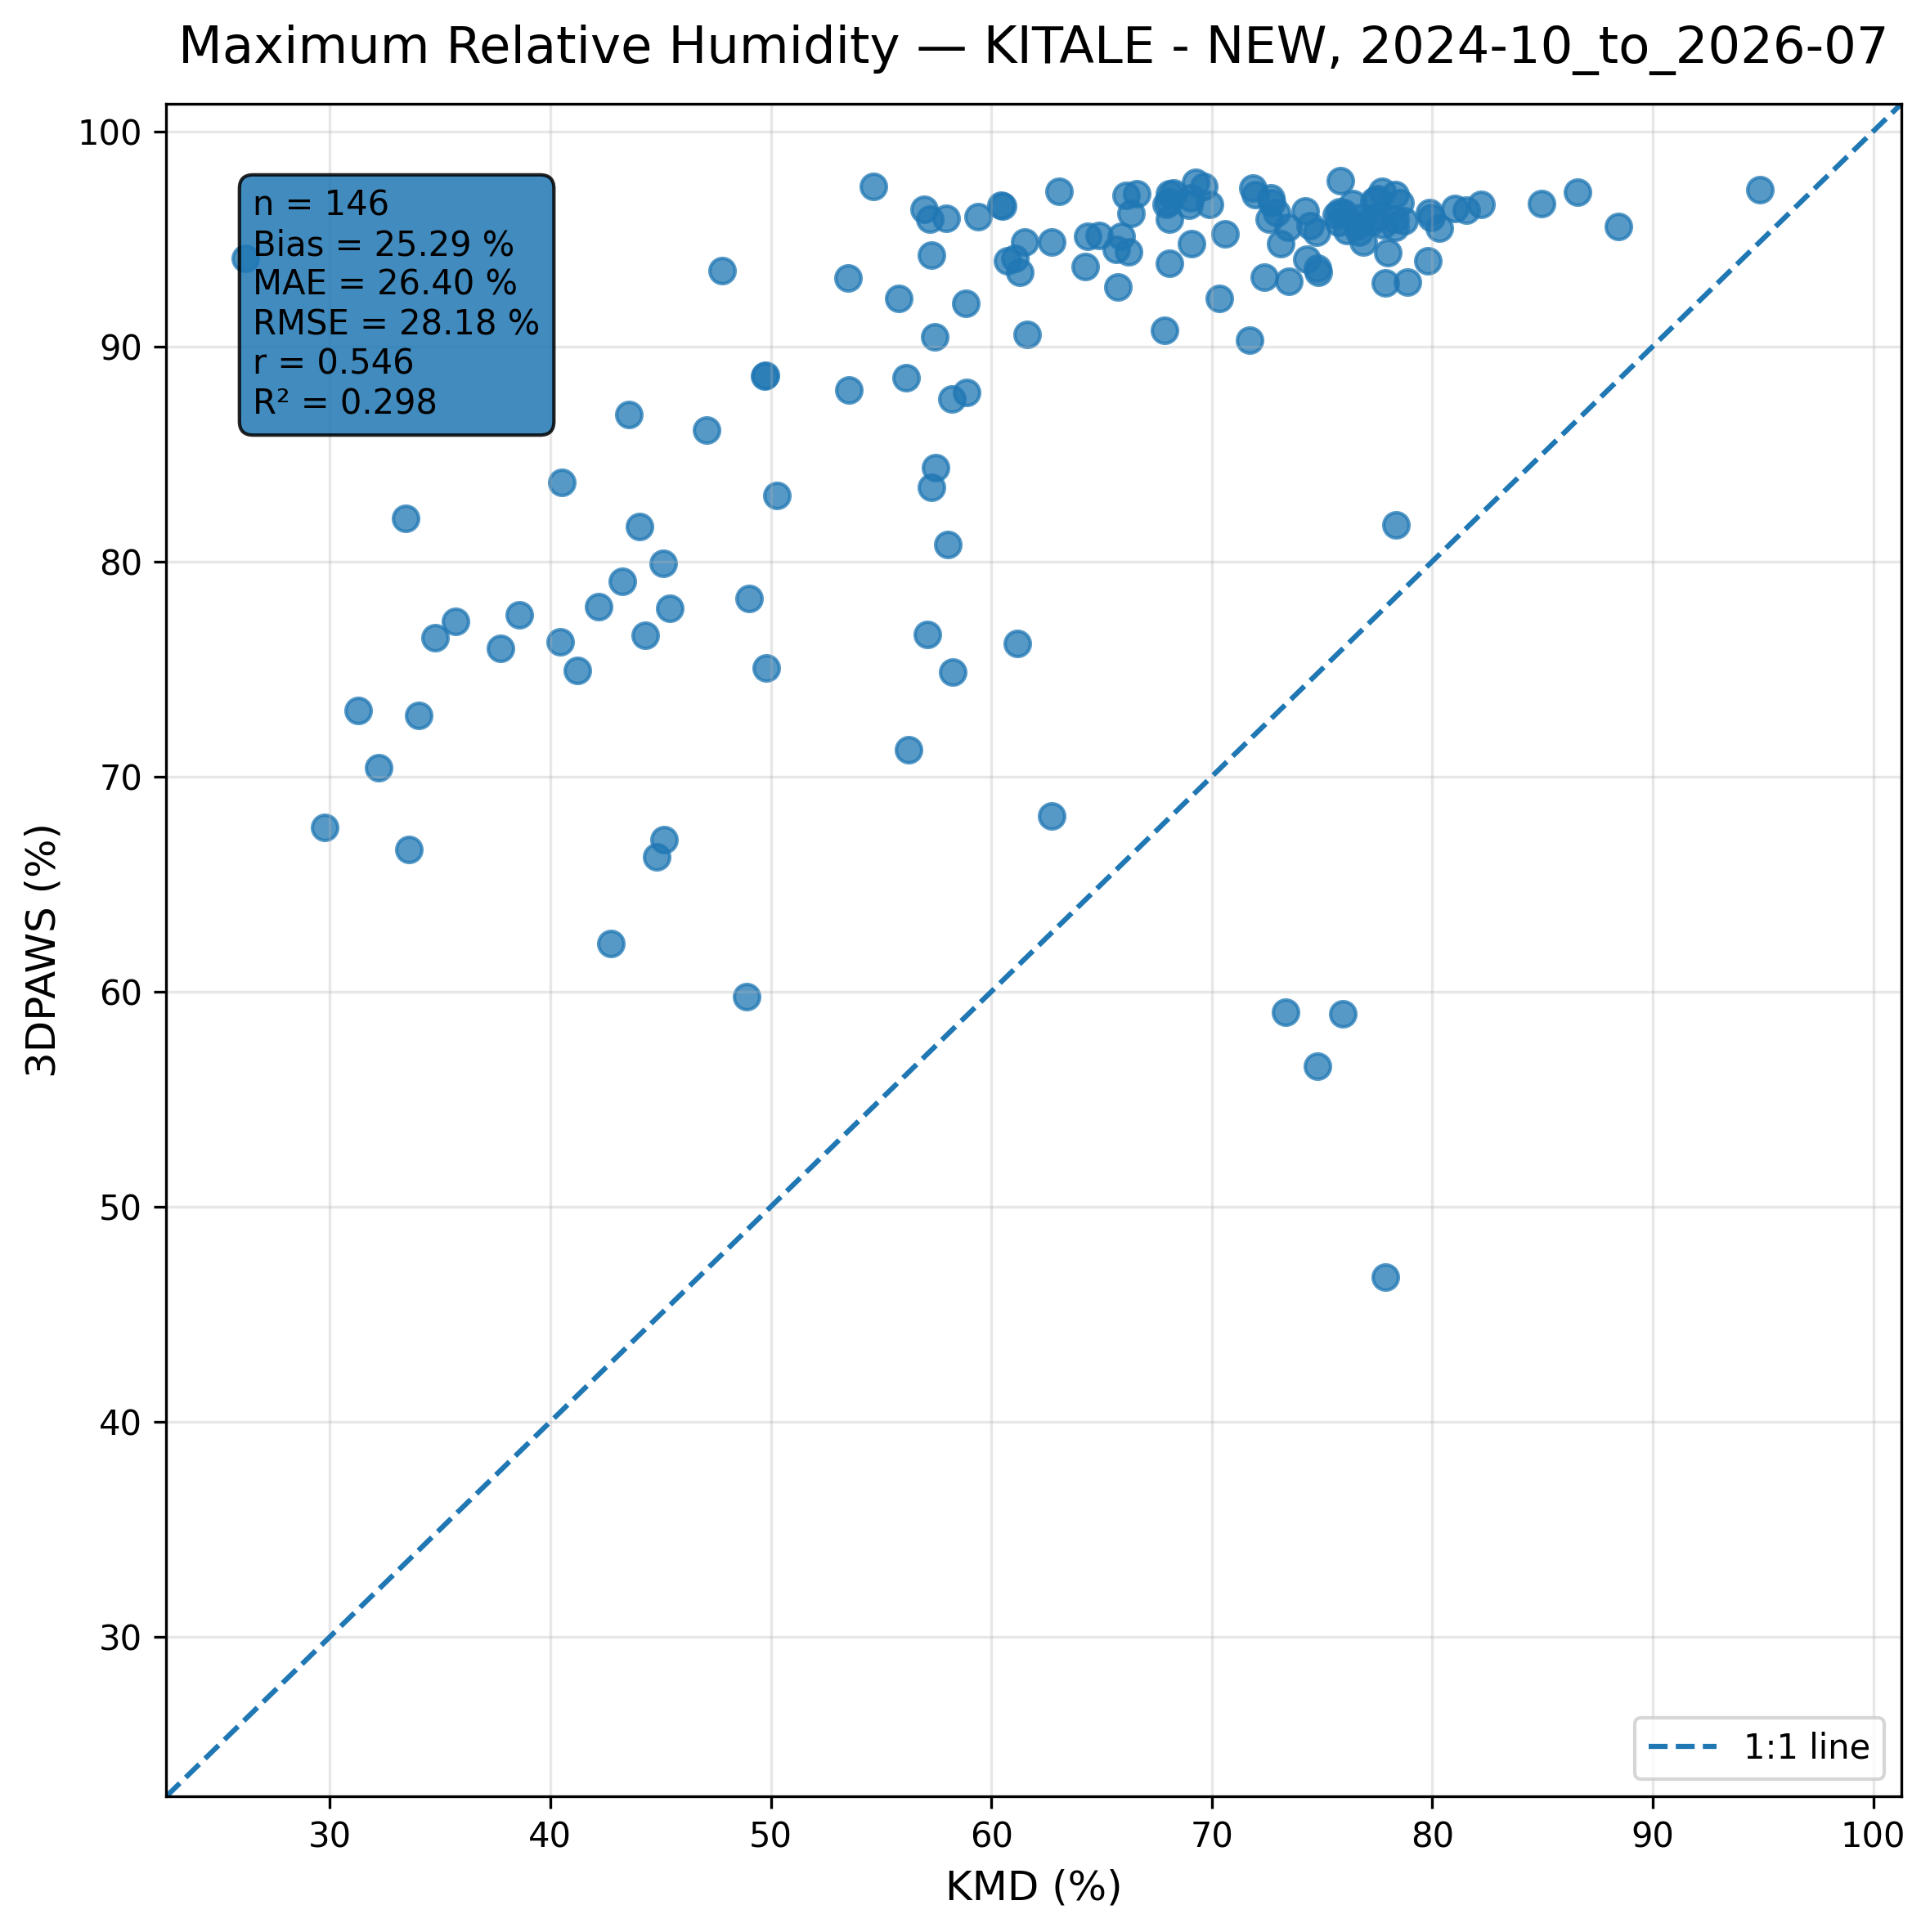
Figure 7.7: Scatter comparison of maximum relative humidity observations between 3DPAWS and KMD at KITALE - NEW for 2024-10_to_2026-07.
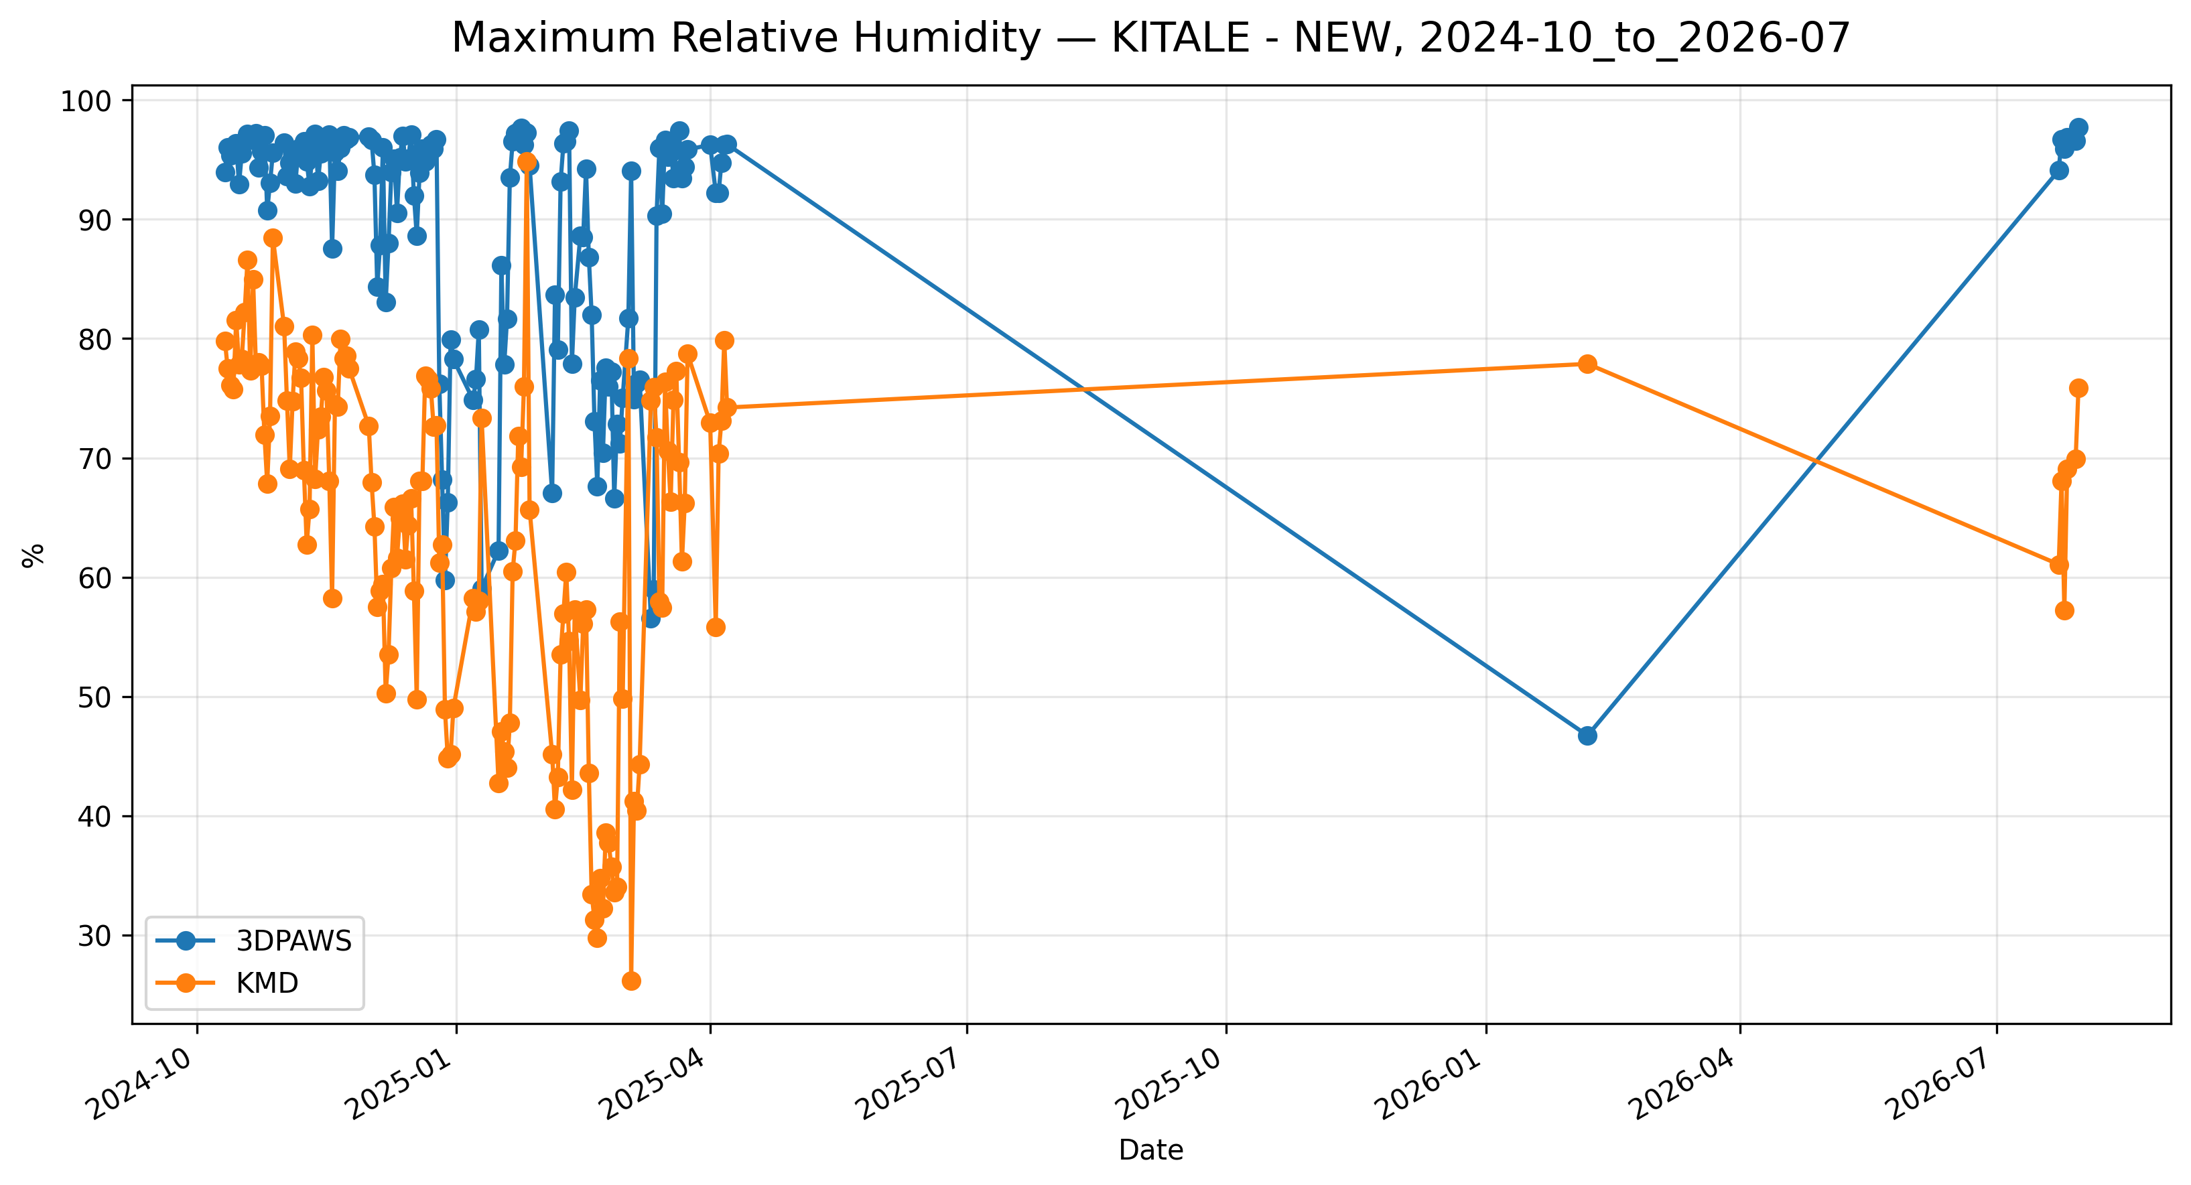
Figure 7.8: Time-series comparison of daily maximum relative humidity observations between 3DPAWS and KMD at KITALE - NEW for 2024-10_to_2026-07.

Minimum Relative Humidity
Data status: HIGH QUALITY | Paired observations: 146 | Comparison missing: 512 | Faulty observations: 6
Descriptive statistics
Statistic | 3DPAWS | KMD
Observations | 146 | 146
Mean | 38.271 | 63.737
Median | 40.415 | 67.220
Minimum | 11.360 | 26.160
Maximum | 96.290 | 94.870
Standard Deviation | 13.049 | 14.483
Variance | 170.283 | 209.758
Validation statistics
Metric | Value
Bias | -25.466 %
Mean Absolute Error (MAE) | 25.995 %
Root Mean Square Error (RMSE) | 27.053 %
Correlation coefficient (r) | 0.783
Coefficient of determination (R²) | 0.614
Performance assessment: Below Threshold
WMO requirement: 776
Criterion | Value
Goal | 0.500 %
Breakthrough | 2.500 %
Threshold | 5.000 %
Interpretation: The paired observations show strong linear agreement between 3DPAWS and KMD measurements (r = 0.783). The coefficient of determination was R² = 0.614. The mean bias was -25.466 %, indicating that the 3DPAWS observations were generally lower than the KMD observations. The mean absolute error was 25.995 %. The root mean square error was 27.053 %. Under the implemented performance assessment criteria, the parameter was classified as Below Threshold. The relatively high correlation indicates that 3D-PAWS successfully captured temporal humidity variability despite differences in absolute values.
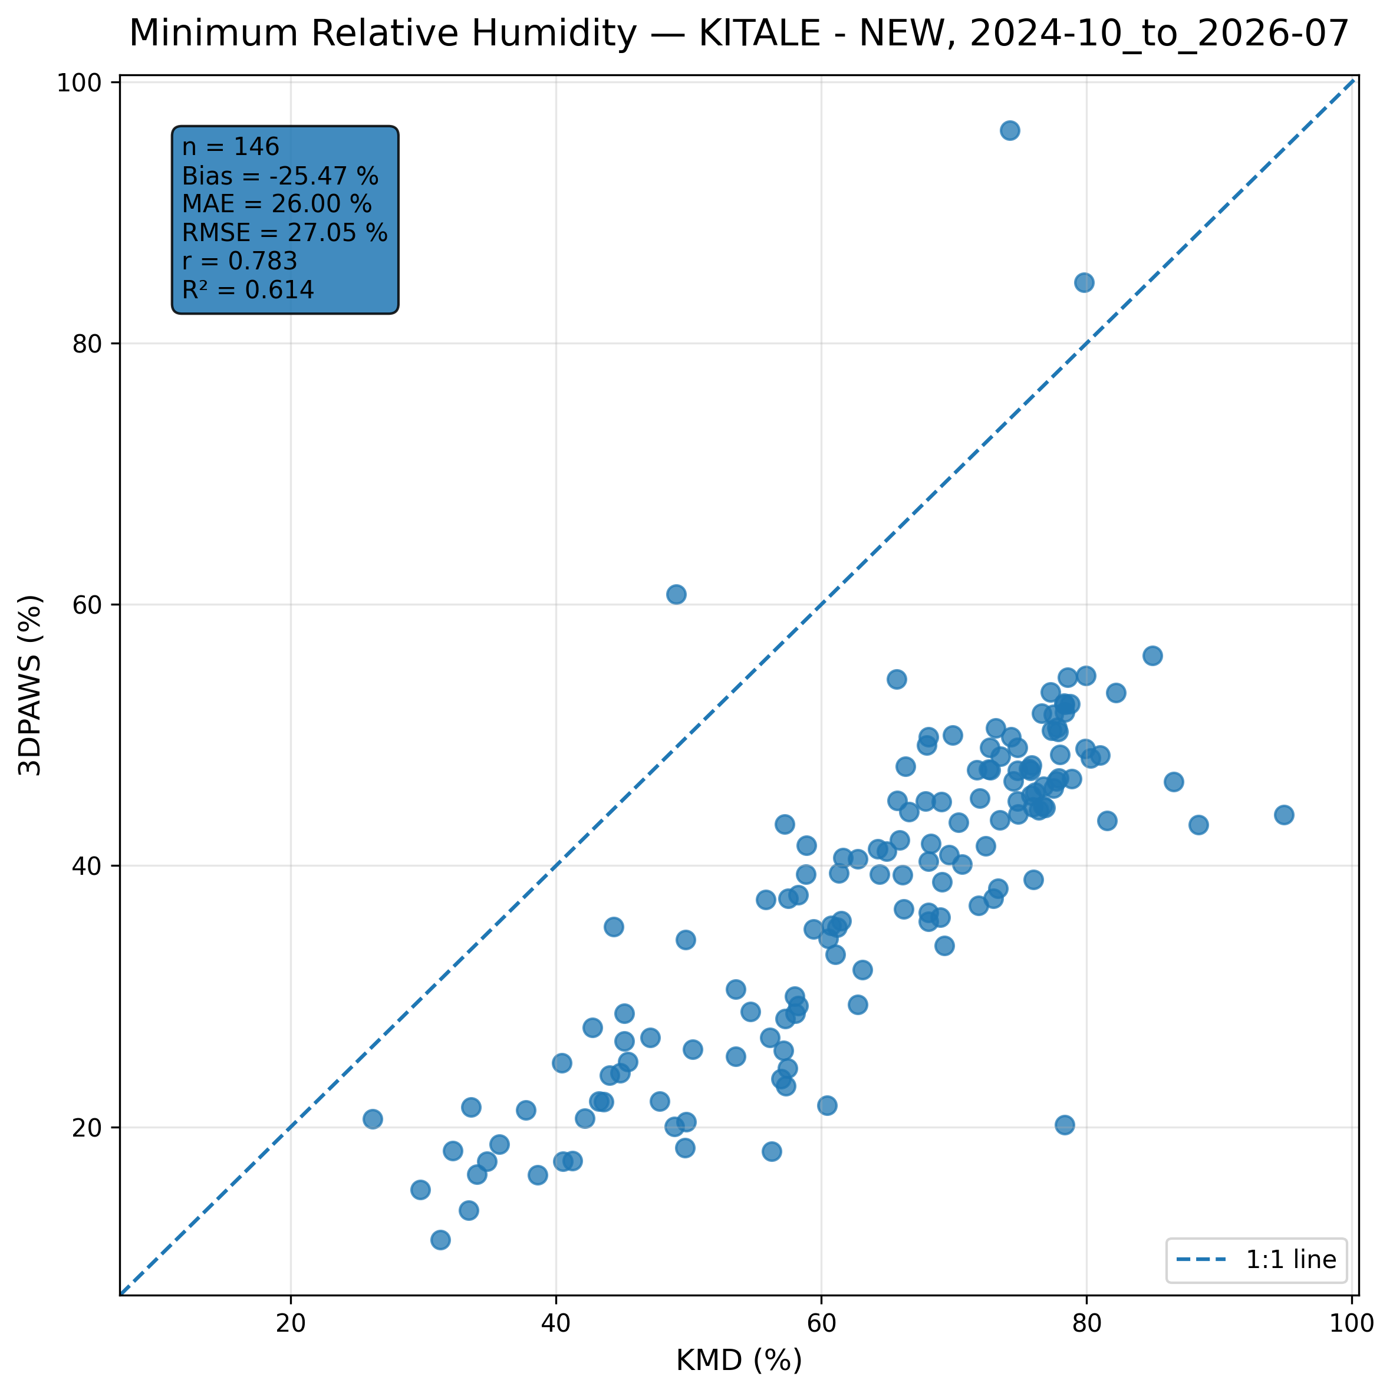
Figure 7.9: Scatter comparison of minimum relative humidity observations between 3DPAWS and KMD at KITALE - NEW for 2024-10_to_2026-07.
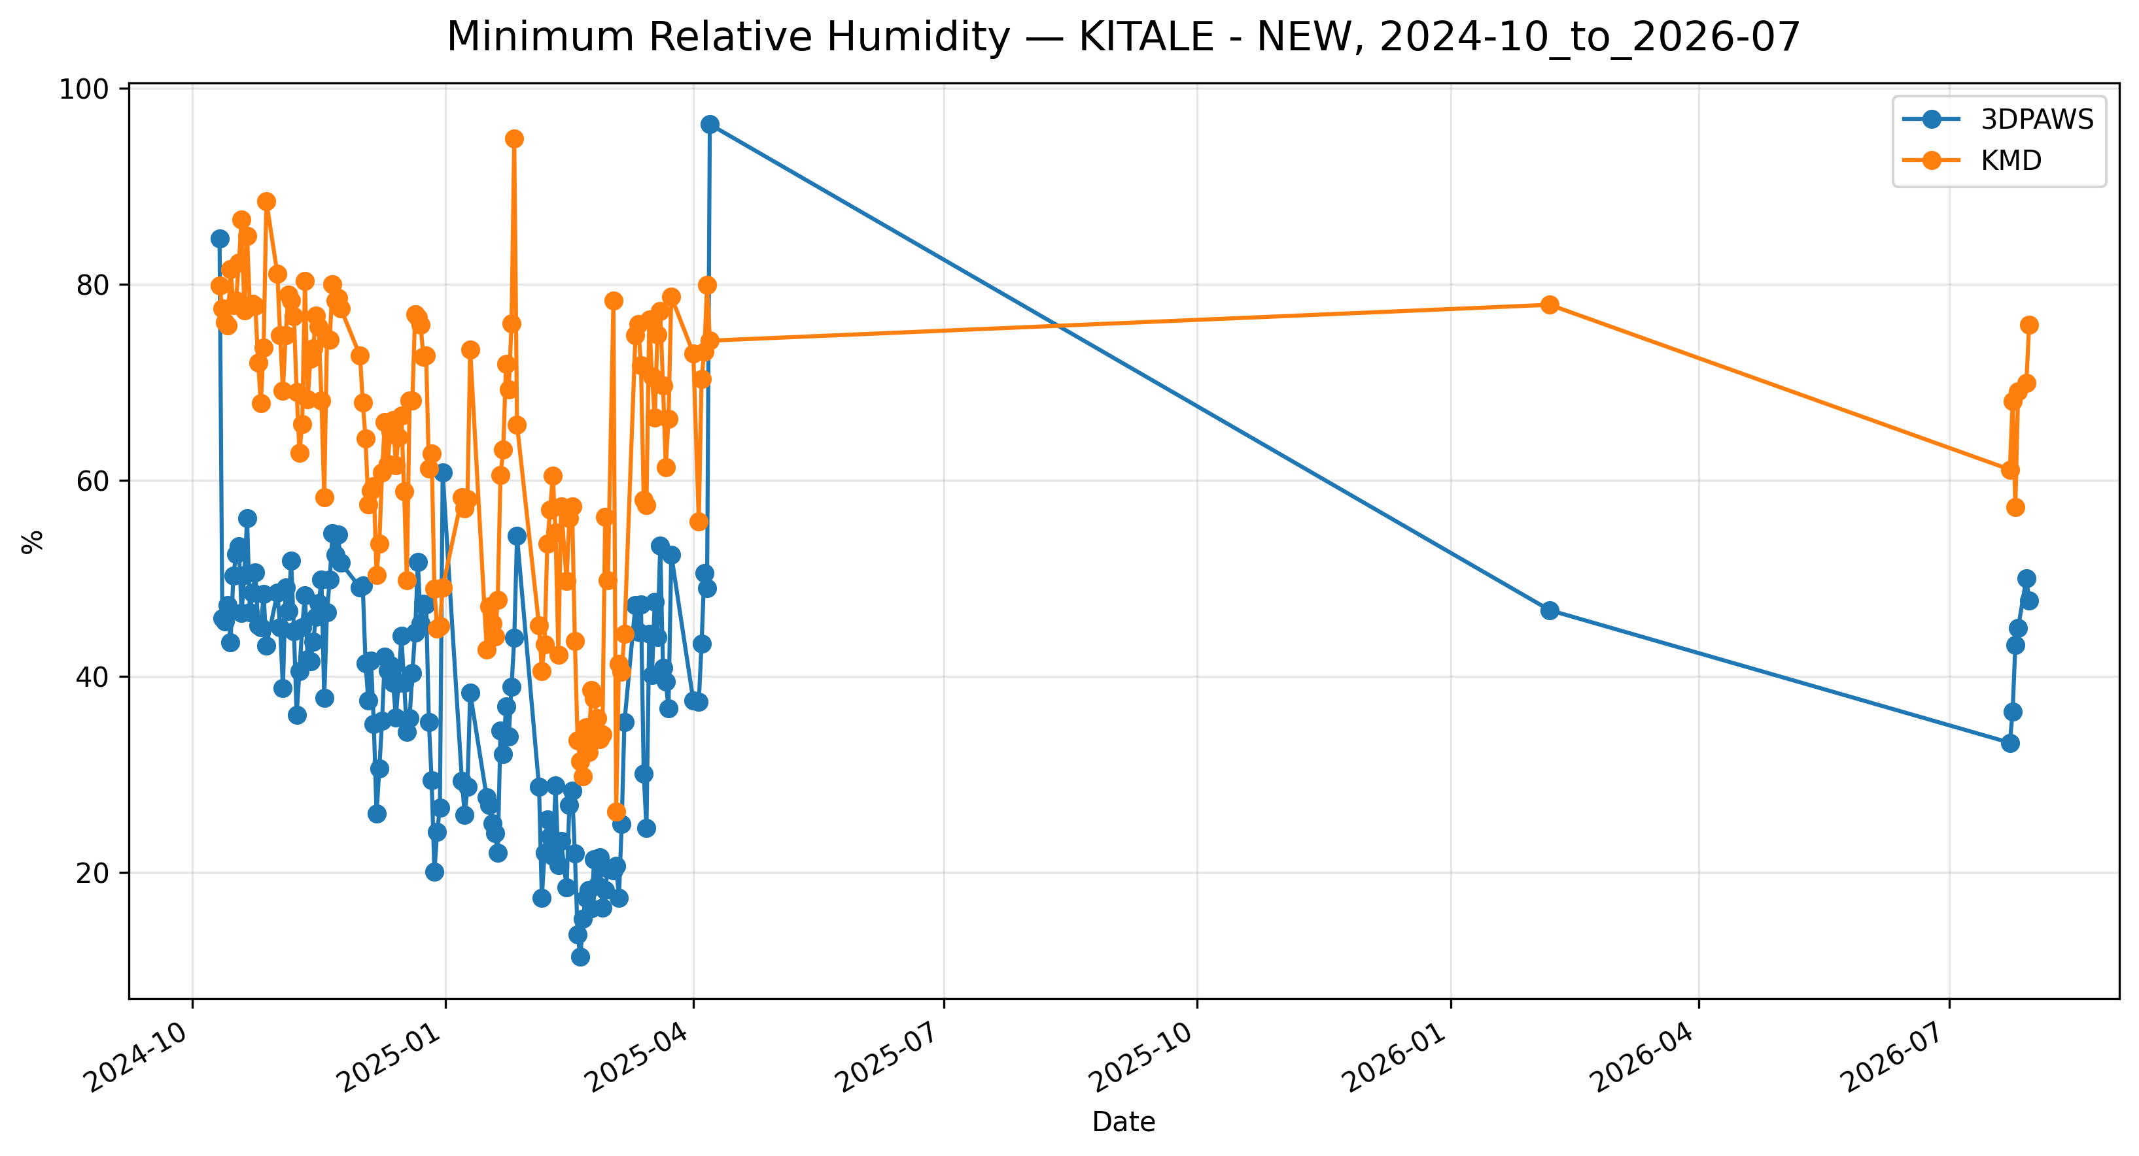
Figure 7.10: Time-series comparison of daily minimum relative humidity observations between 3DPAWS and KMD at KITALE - NEW for 2024-10_to_2026-07.

Mean Relative Humidity
Data status: HIGH QUALITY | Paired observations: 146 | Comparison missing: 512 | Faulty observations: 6
Descriptive statistics
Statistic | 3DPAWS | KMD
Observations | 146 | 146
Mean | 66.392 | 63.737
Median | 70.446 | 67.220
Minimum | 35.662 | 26.160
Maximum | 96.290 | 94.870
Standard Deviation | 14.267 | 14.483
Variance | 203.556 | 209.758
Validation statistics
Metric | Value
Bias | 2.655 %
Mean Absolute Error (MAE) | 6.206 %
Root Mean Square Error (RMSE) | 8.701 %
Correlation coefficient (r) | 0.833
Coefficient of determination (R²) | 0.694
Performance assessment: Below Threshold
WMO requirement: 776
Criterion | Value
Goal | 0.500 %
Breakthrough | 2.500 %
Threshold | 5.000 %
Interpretation: The paired observations show strong linear agreement between 3DPAWS and KMD measurements (r = 0.833). The coefficient of determination was R² = 0.694. The mean bias was 2.655 %, indicating that the 3DPAWS observations were generally higher than the KMD observations. The mean absolute error was 6.206 %. The root mean square error was 8.701 %. Under the implemented performance assessment criteria, the parameter was classified as Below Threshold. The relatively high correlation indicates that 3D-PAWS successfully captured temporal humidity variability despite differences in absolute values.
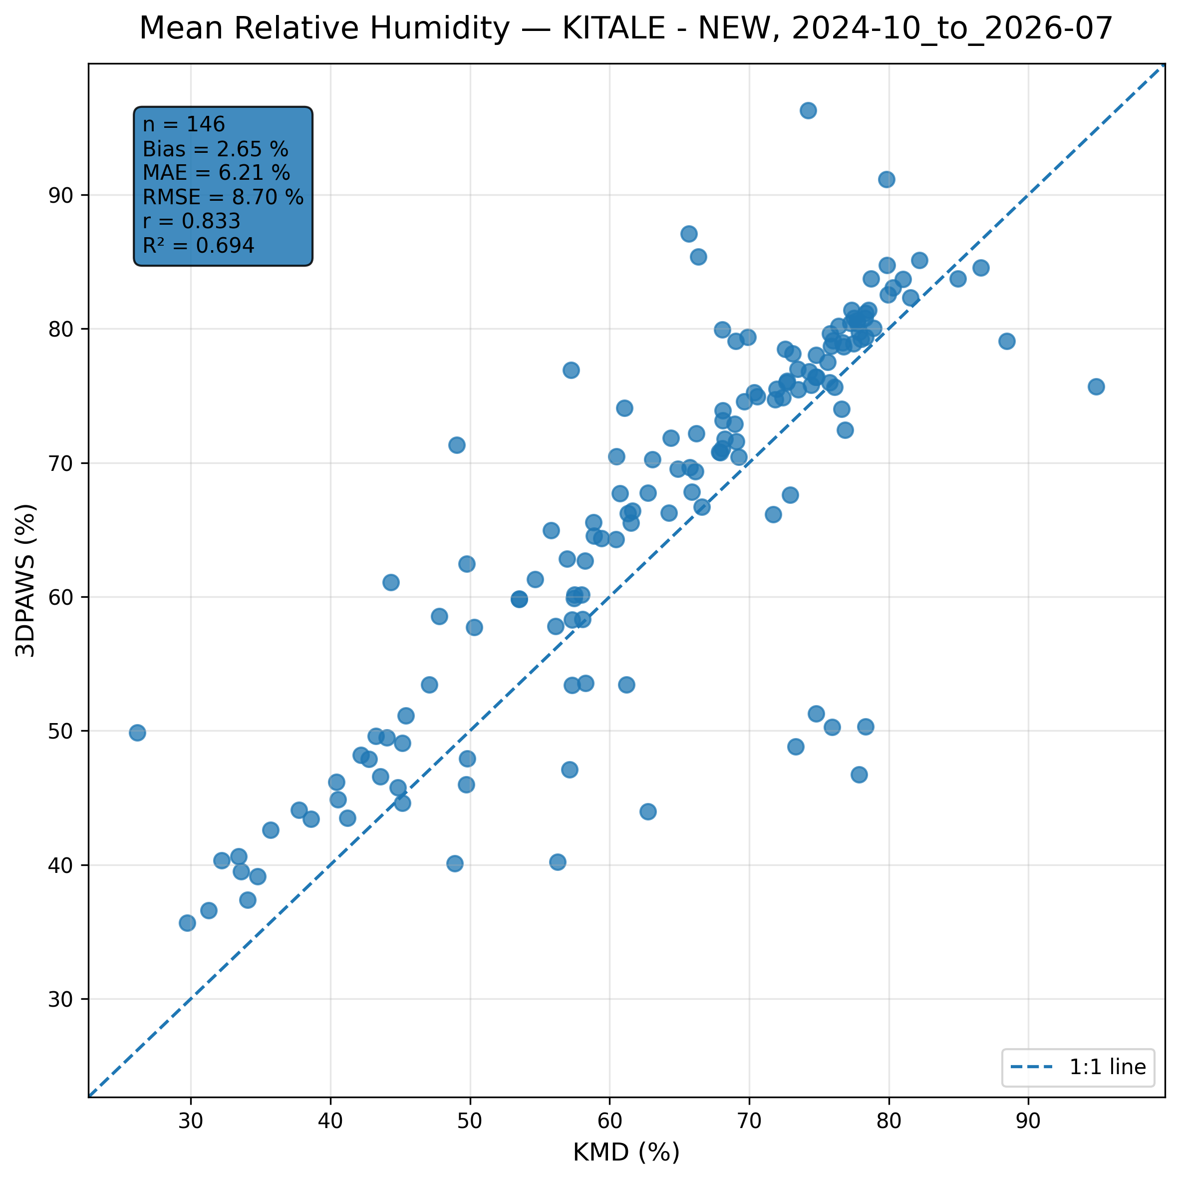
Figure 7.11: Scatter comparison of mean relative humidity observations between 3DPAWS and KMD at KITALE - NEW for 2024-10_to_2026-07.
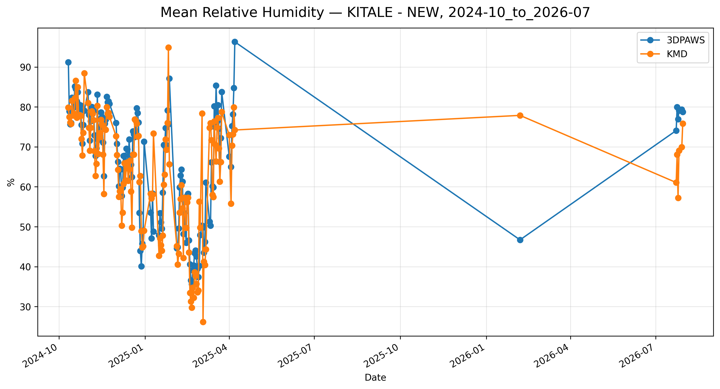
Figure 7.12: Time-series comparison of daily mean relative humidity observations between 3DPAWS and KMD at KITALE - NEW for 2024-10_to_2026-07.

7.6 Pressure Results

Maximum Pressure
Data status: HIGH QUALITY | Paired observations: 146 | Comparison missing: 512 | Faulty observations: 16
Descriptive statistics
Statistic | 3DPAWS | KMD
Observations | 146 | 146
Mean | 828.419 | 823.568
Median | 820.616 | 823.735
Minimum | 817.730 | 818.830
Maximum | 999.678 | 827.070
Standard Deviation | 17.810 | 1.314
Variance | 317.211 | 1.727
Validation statistics
Metric | Value
Bias | 4.851 hPa
Mean Absolute Error (MAE) | 9.449 hPa
Root Mean Square Error (RMSE) | 18.280 hPa
Correlation coefficient (r) | 0.132
Coefficient of determination (R²) | 0.017
Performance assessment: Below Threshold
WMO requirement: 250
Criterion | Value
Goal | 0.500 hPa
Breakthrough | 1.000 hPa
Threshold | 1.000 hPa
Interpretation: The paired observations show very weak linear agreement between 3DPAWS and KMD measurements (r = 0.132). The coefficient of determination was R² = 0.017. The mean bias was 4.851 hPa, indicating that the 3DPAWS observations were generally higher than the KMD observations. The mean absolute error was 9.449 hPa. The root mean square error was 18.280 hPa. Under the implemented performance assessment criteria, the parameter was classified as Below Threshold. Differences in pressure variability may be associated with elevation correction, sensor response characteristics, or local exposure conditions.
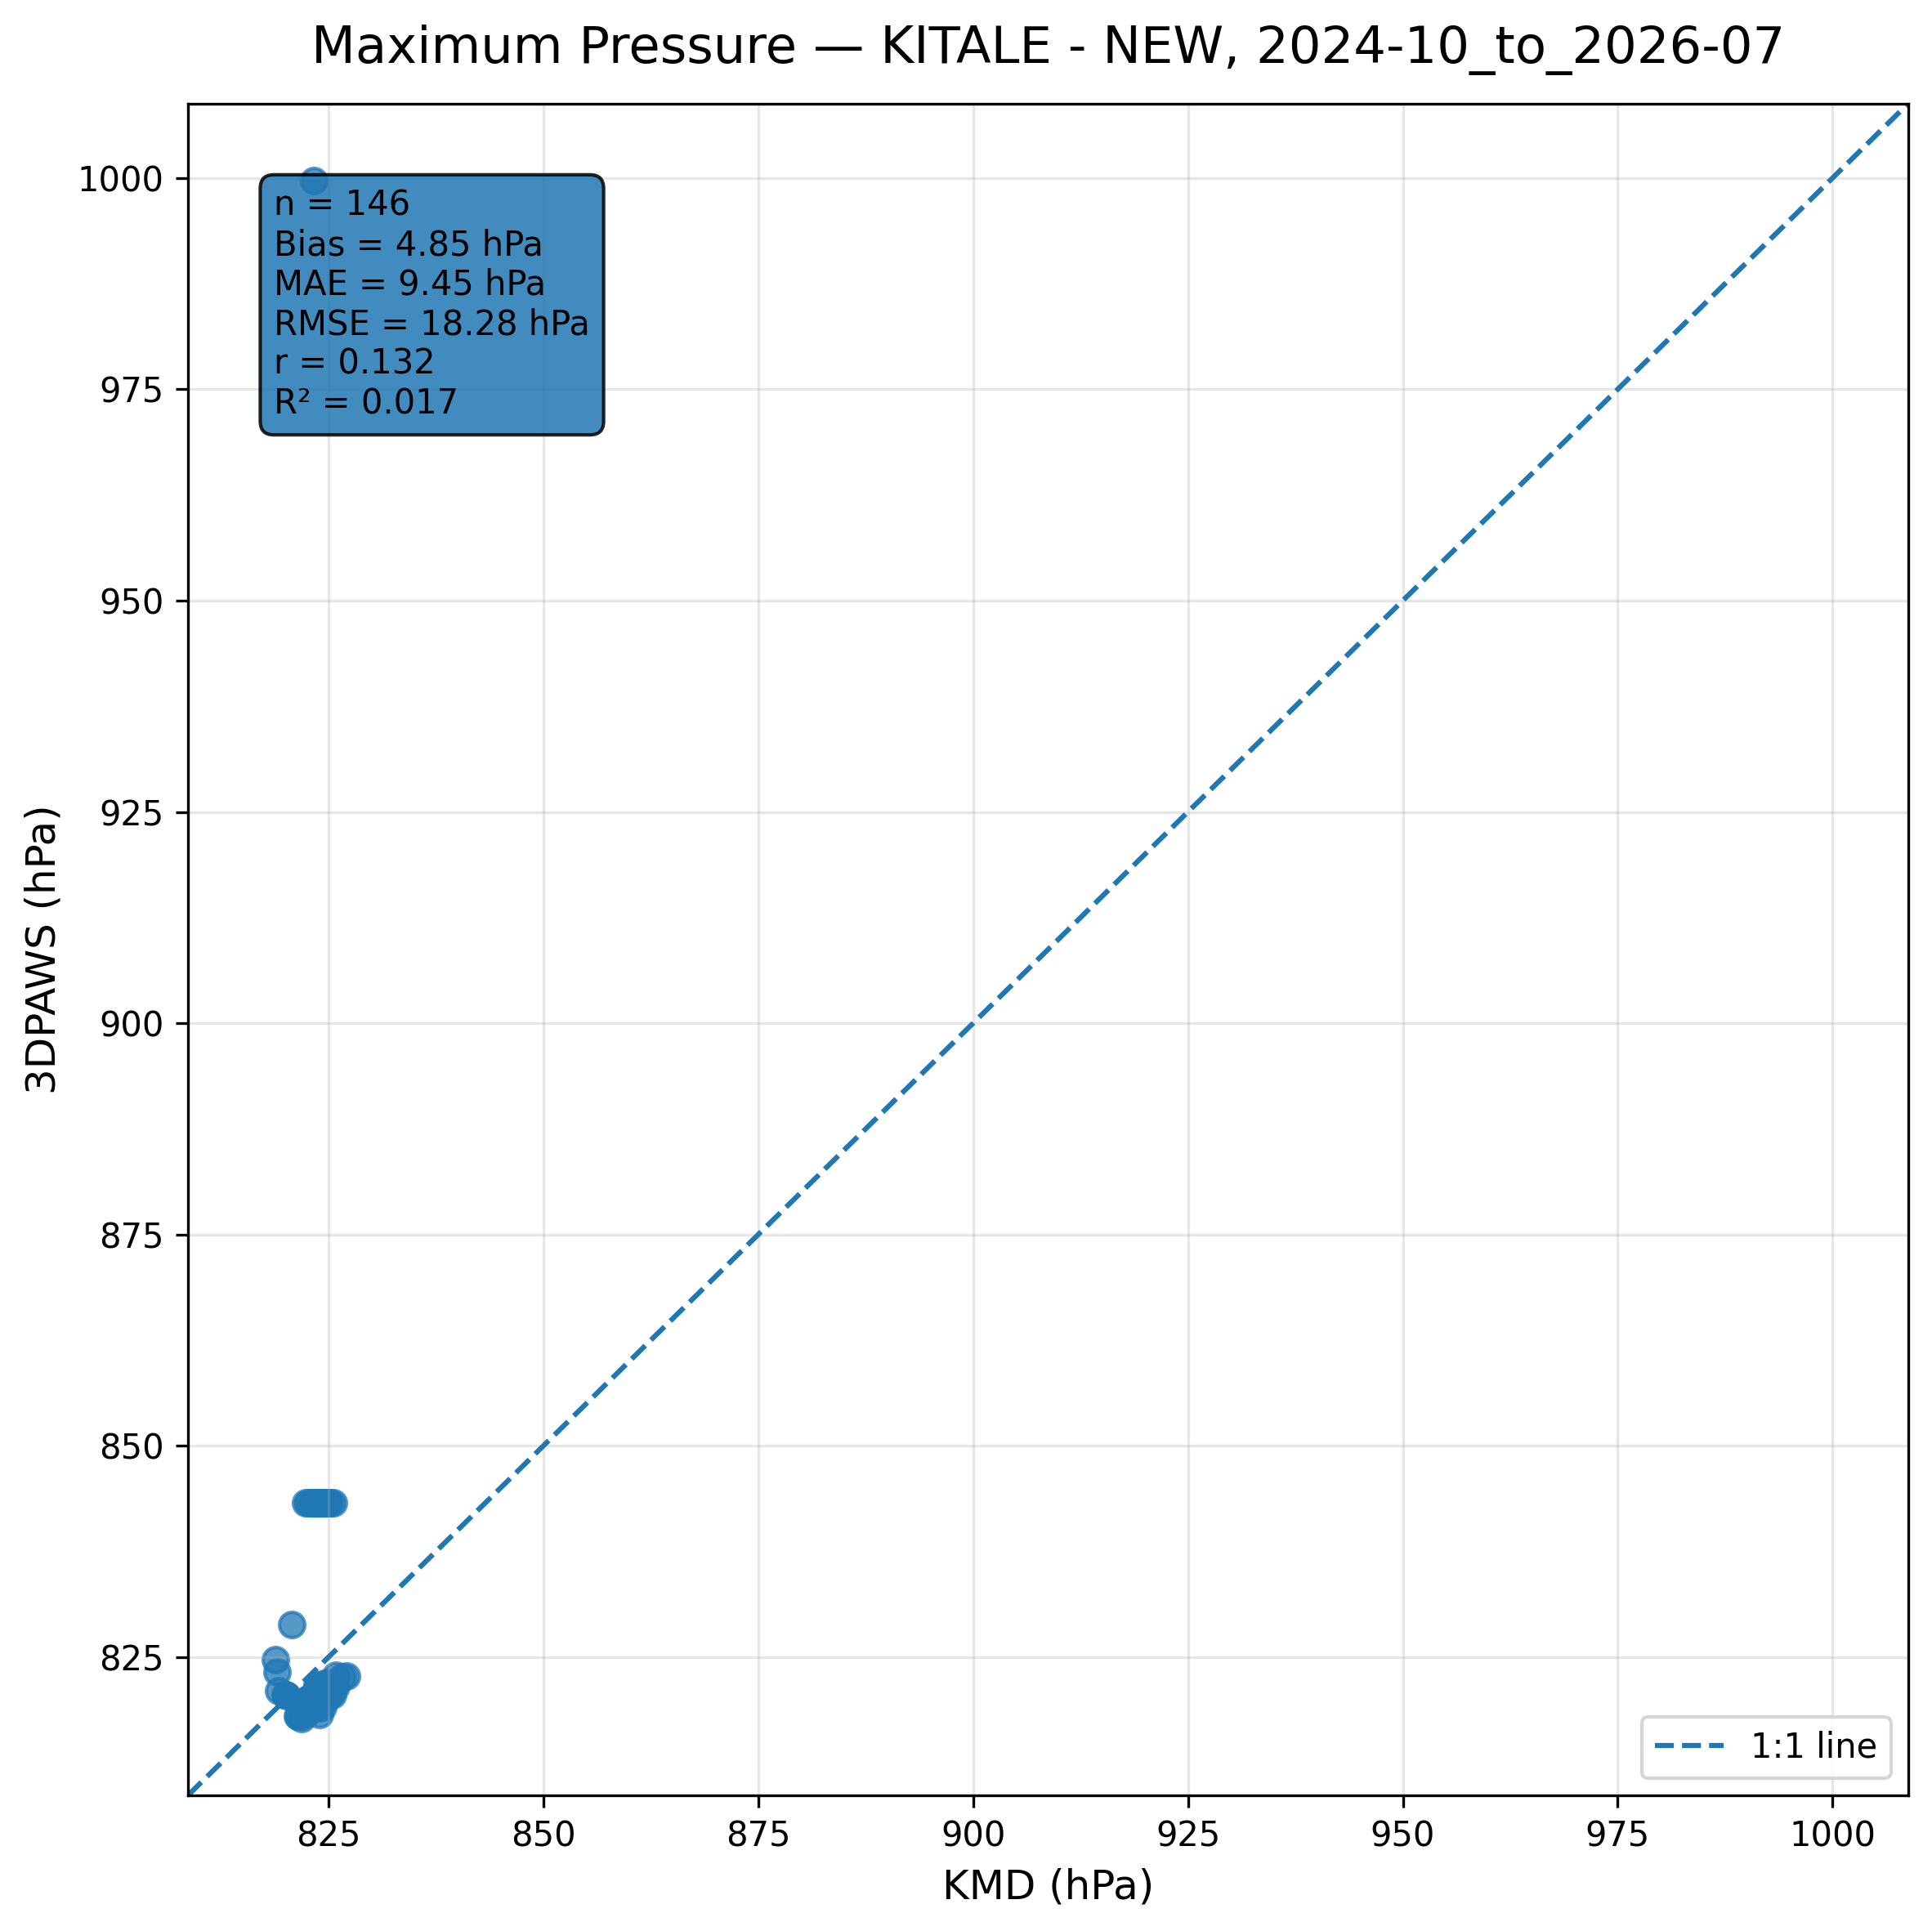
Figure 7.13: Scatter comparison of maximum pressure observations between 3DPAWS and KMD at KITALE - NEW for 2024-10_to_2026-07.
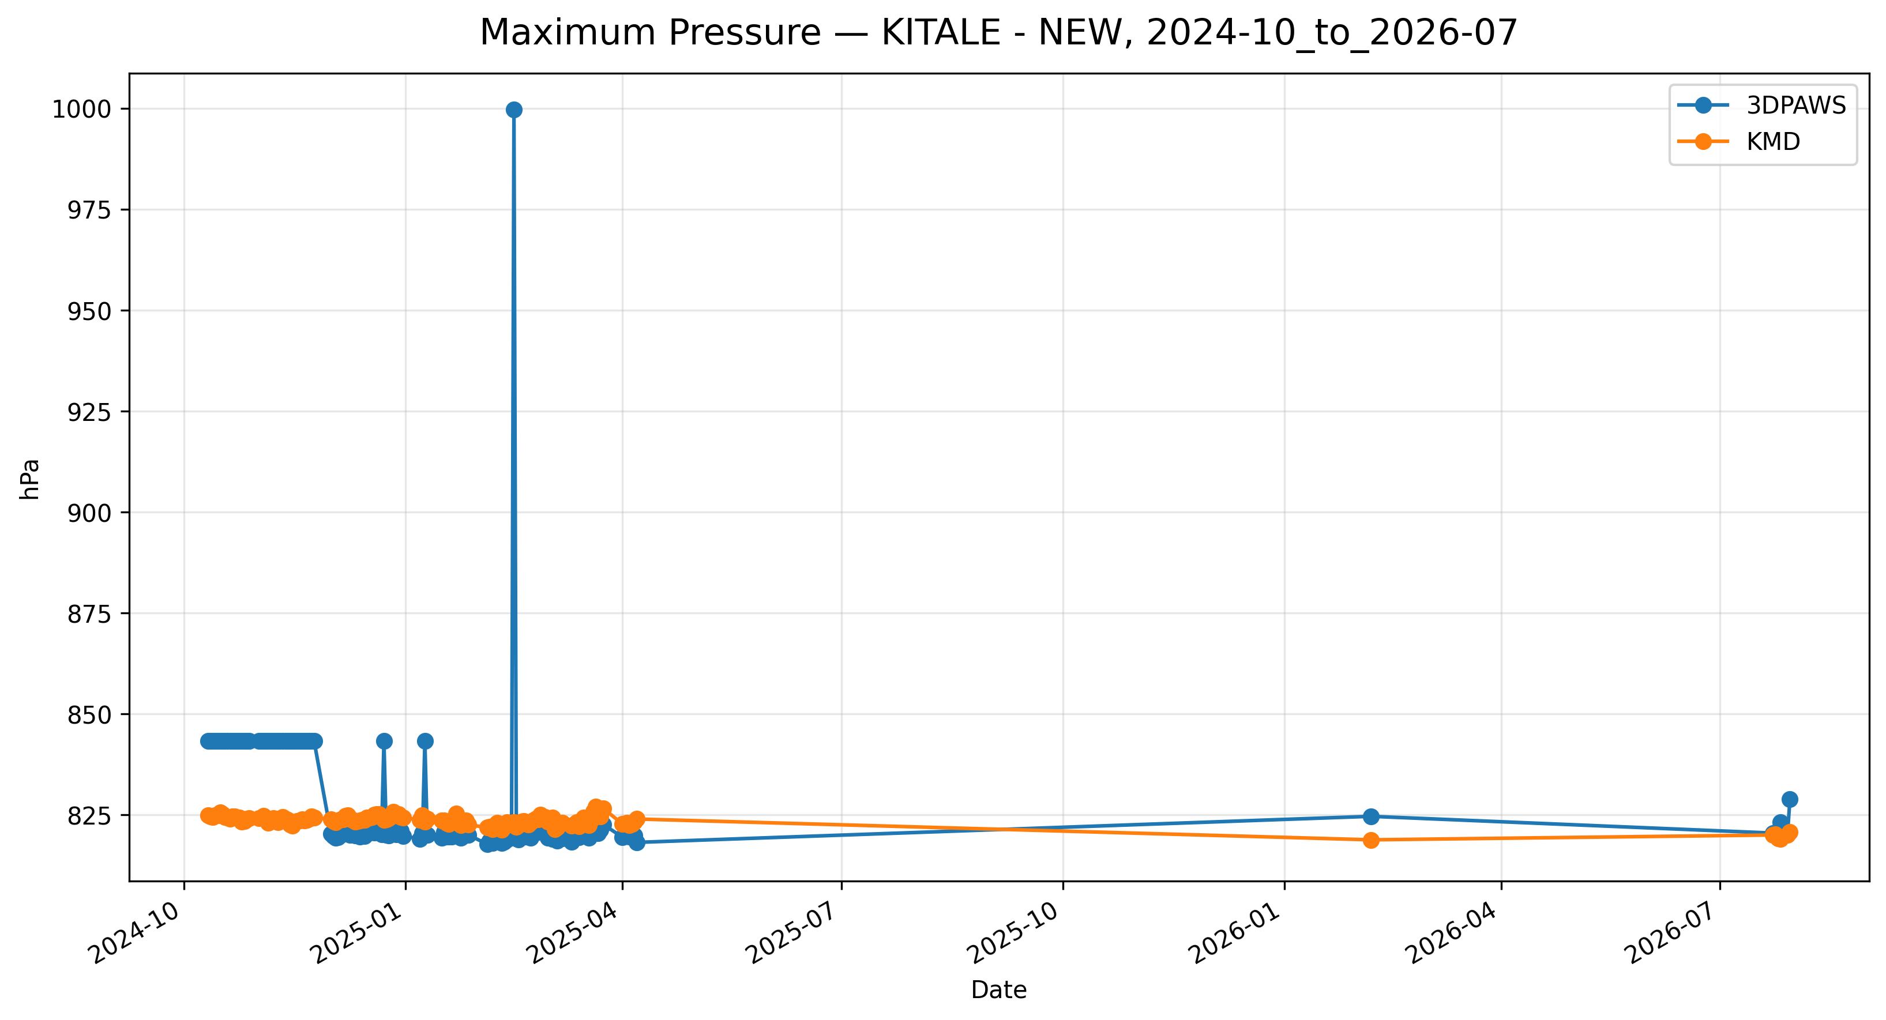
Figure 7.14: Time-series comparison of daily maximum pressure observations between 3DPAWS and KMD at KITALE - NEW for 2024-10_to_2026-07.

Minimum Pressure
Data status: HIGH QUALITY | Paired observations: 146 | Comparison missing: 512 | Faulty observations: 16
Descriptive statistics
Statistic | 3DPAWS | KMD
Observations | 146 | 146
Mean | 815.727 | 823.568
Median | 815.807 | 823.735
Minimum | 810.700 | 818.830
Maximum | 824.651 | 827.070
Standard Deviation | 1.543 | 1.314
Variance | 2.382 | 1.727
Validation statistics
Metric | Value
Bias | -7.841 hPa
Mean Absolute Error (MAE) | 7.921 hPa
Root Mean Square Error (RMSE) | 7.954 hPa
Correlation coefficient (r) | 0.570
Coefficient of determination (R²) | 0.324
Performance assessment: Below Threshold
WMO requirement: 250
Criterion | Value
Goal | 0.500 hPa
Breakthrough | 1.000 hPa
Threshold | 1.000 hPa
Interpretation: The paired observations show moderate linear agreement between 3DPAWS and KMD measurements (r = 0.570). The coefficient of determination was R² = 0.324. The mean bias was -7.841 hPa, indicating that the 3DPAWS observations were generally lower than the KMD observations. The mean absolute error was 7.921 hPa. The root mean square error was 7.954 hPa. Under the implemented performance assessment criteria, the parameter was classified as Below Threshold. Differences in pressure variability may be associated with elevation correction, sensor response characteristics, or local exposure conditions.
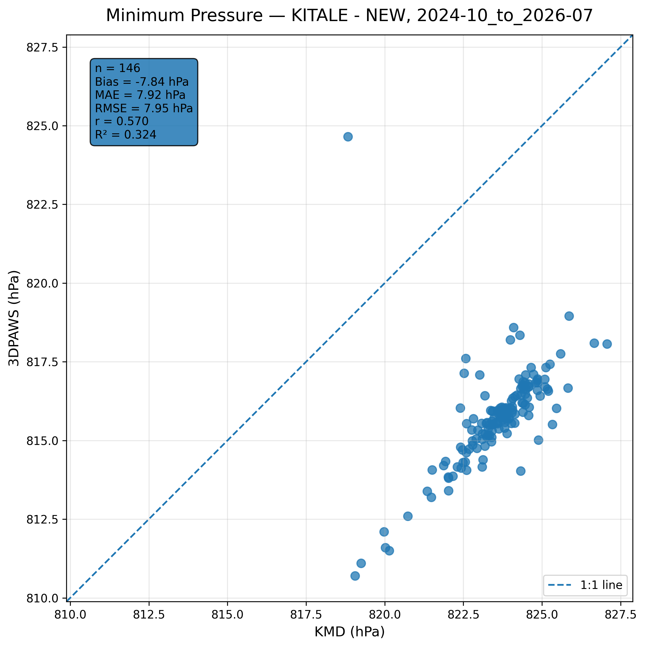
Figure 7.15: Scatter comparison of minimum pressure observations between 3DPAWS and KMD at KITALE - NEW for 2024-10_to_2026-07.
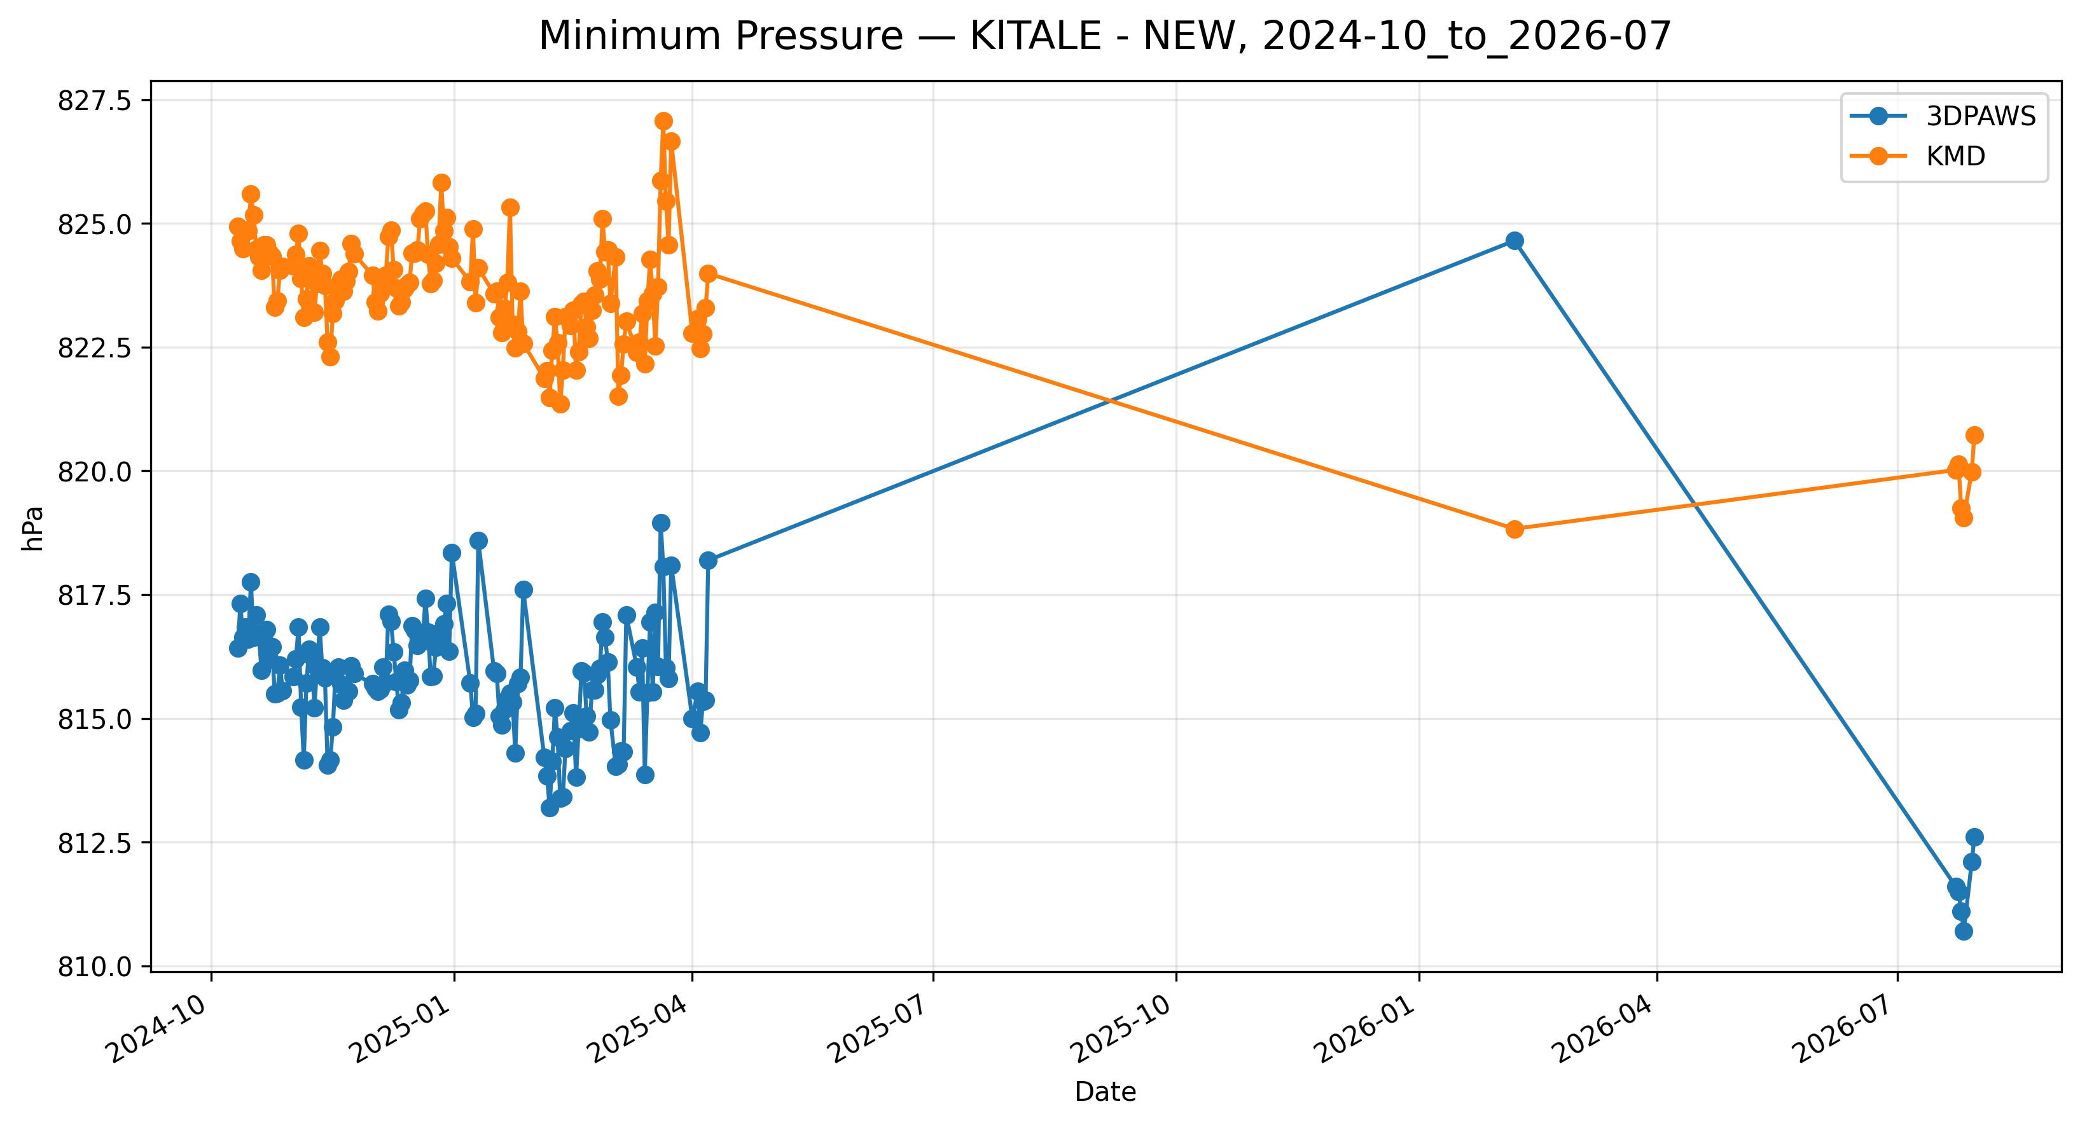
Figure 7.16: Time-series comparison of daily minimum pressure observations between 3DPAWS and KMD at KITALE - NEW for 2024-10_to_2026-07.

Mean Pressure
Data status: HIGH QUALITY | Paired observations: 146 | Comparison missing: 512 | Faulty observations: 16
Descriptive statistics
Statistic | 3DPAWS | KMD
Observations | 146 | 146
Mean | 818.173 | 823.568
Median | 818.175 | 823.735
Minimum | 815.172 | 818.830
Maximum | 826.951 | 827.070
Standard Deviation | 1.343 | 1.314
Variance | 1.804 | 1.727
Validation statistics
Metric | Value
Bias | -5.395 hPa
Mean Absolute Error (MAE) | 5.526 hPa
Root Mean Square Error (RMSE) | 5.561 hPa
Correlation coefficient (r) | 0.481
Coefficient of determination (R²) | 0.231
Performance assessment: Below Threshold
WMO requirement: 250
Criterion | Value
Goal | 0.500 hPa
Breakthrough | 1.000 hPa
Threshold | 1.000 hPa
Interpretation: The paired observations show weak linear agreement between 3DPAWS and KMD measurements (r = 0.481). The coefficient of determination was R² = 0.231. The mean bias was -5.395 hPa, indicating that the 3DPAWS observations were generally lower than the KMD observations. The mean absolute error was 5.526 hPa. The root mean square error was 5.561 hPa. Under the implemented performance assessment criteria, the parameter was classified as Below Threshold. Differences in pressure variability may be associated with elevation correction, sensor response characteristics, or local exposure conditions.
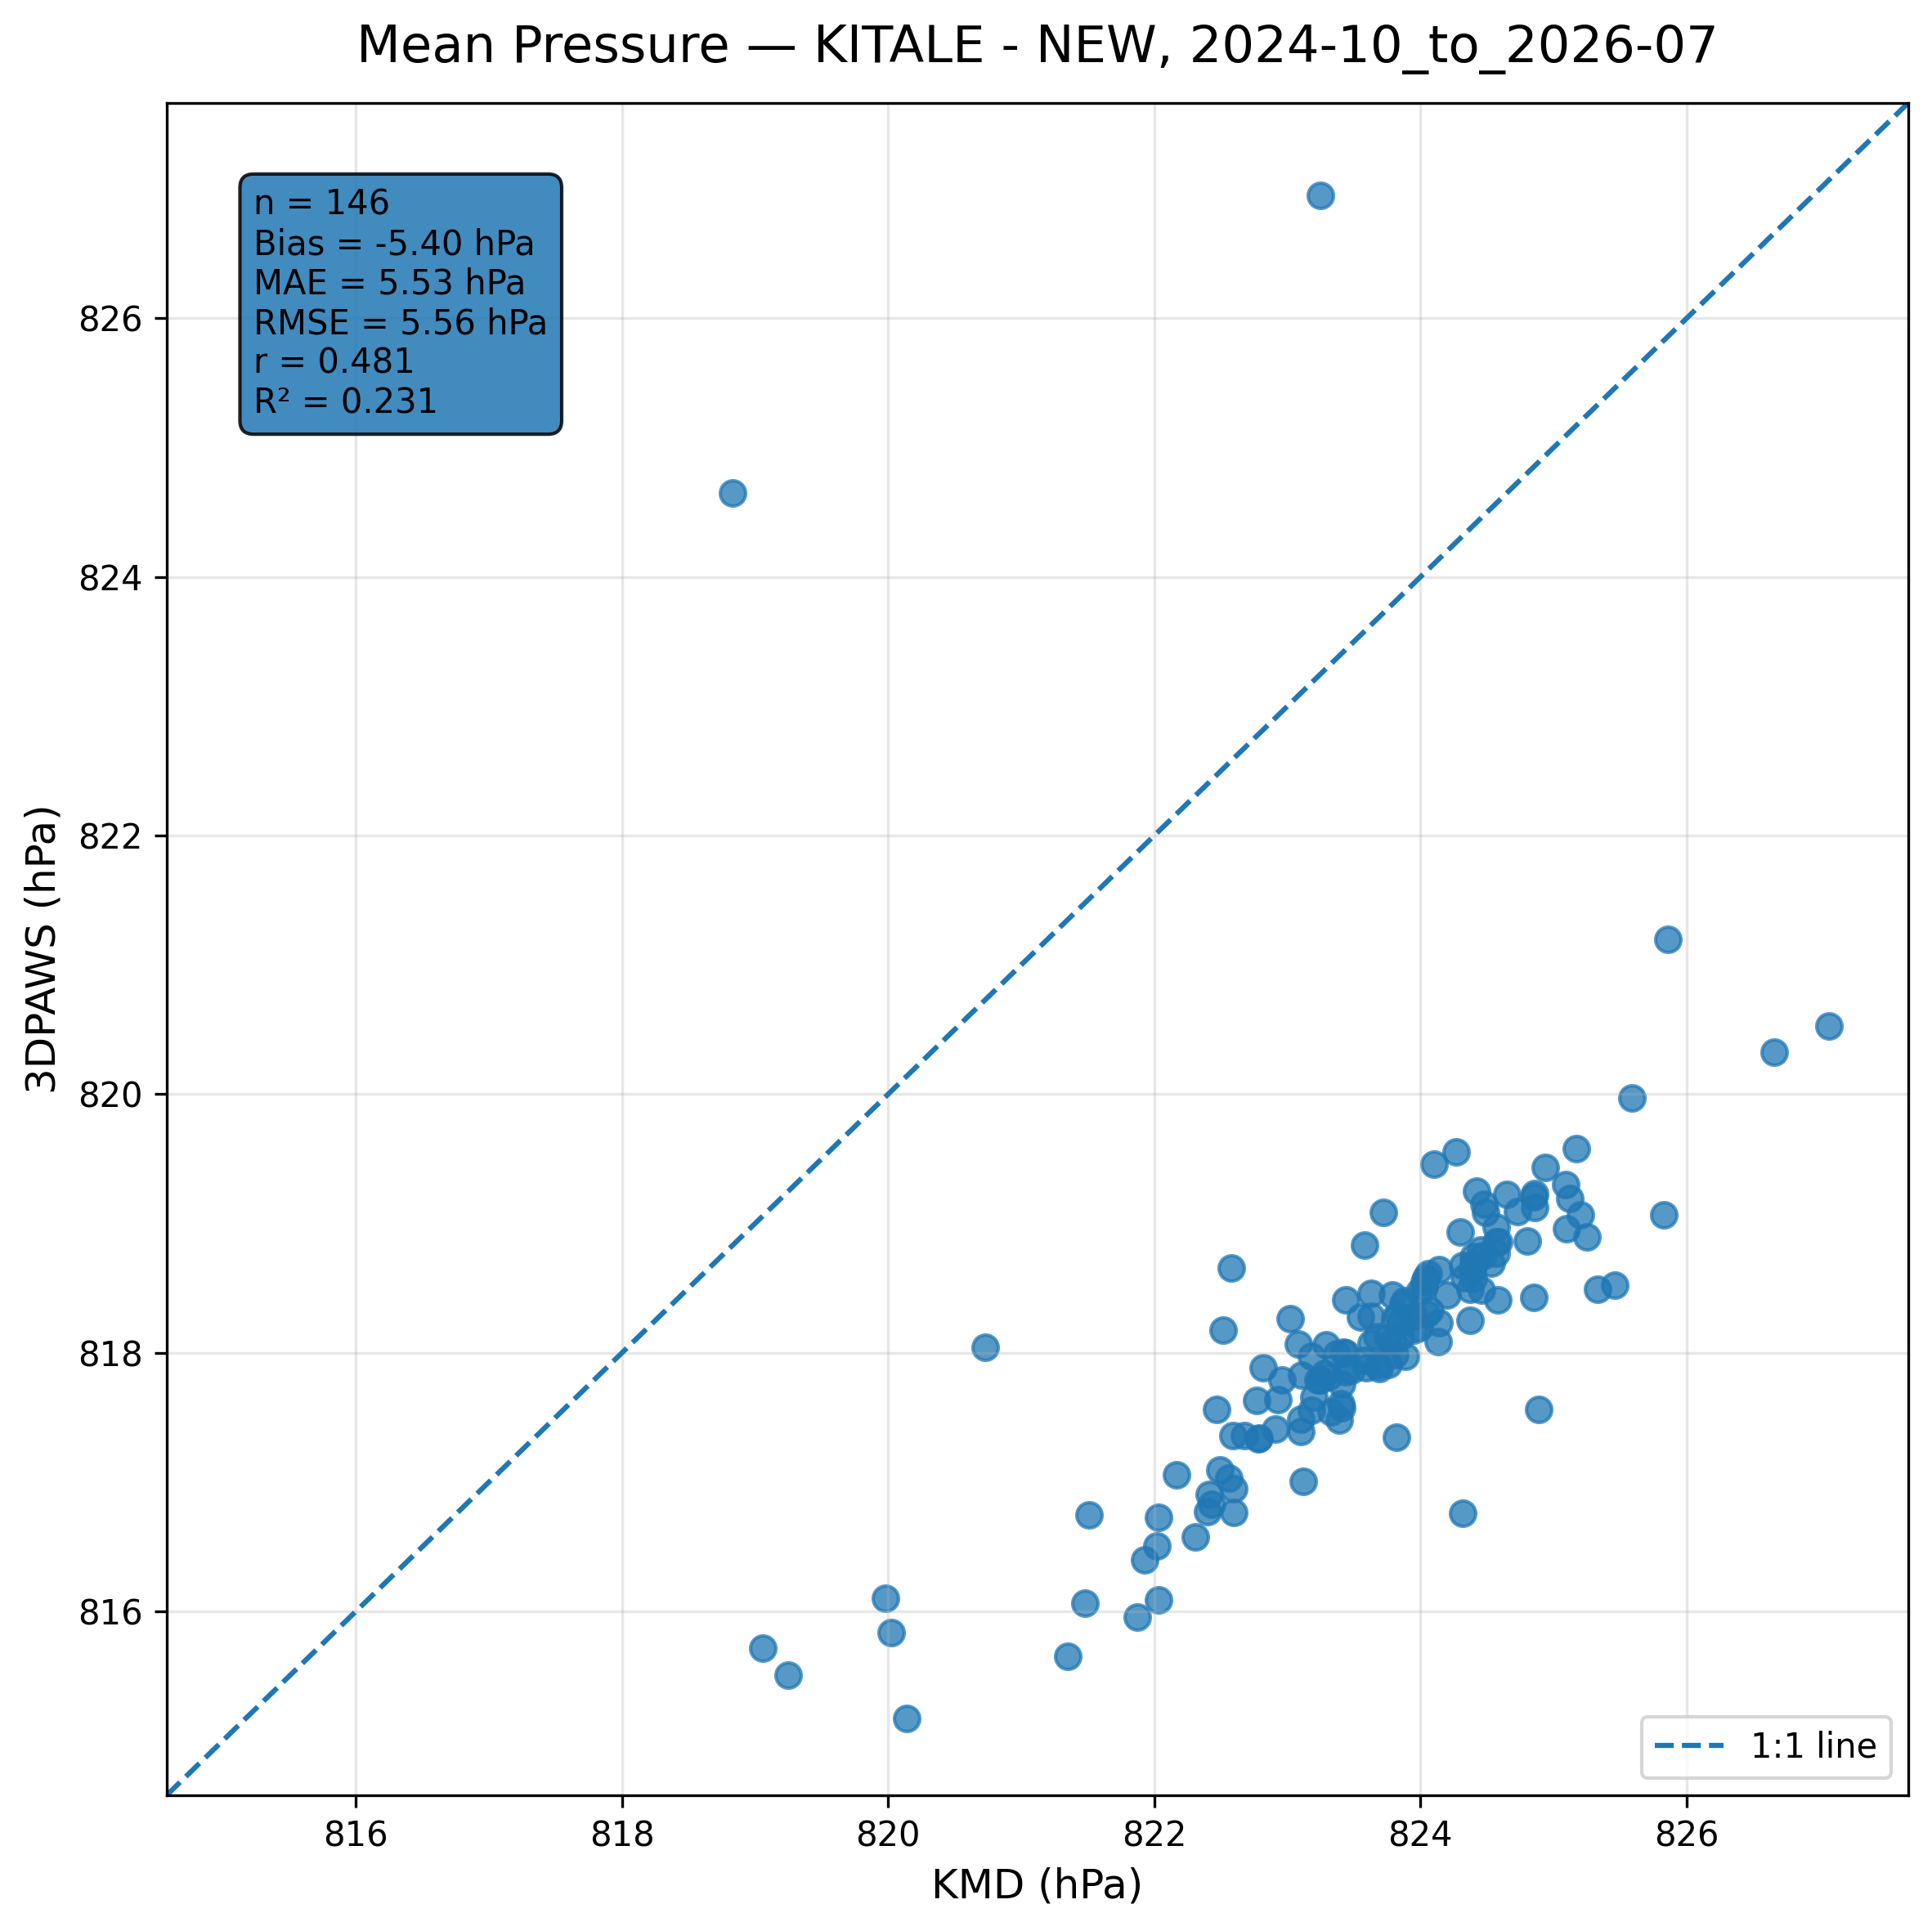
Figure 7.17: Scatter comparison of mean pressure observations between 3DPAWS and KMD at KITALE - NEW for 2024-10_to_2026-07.
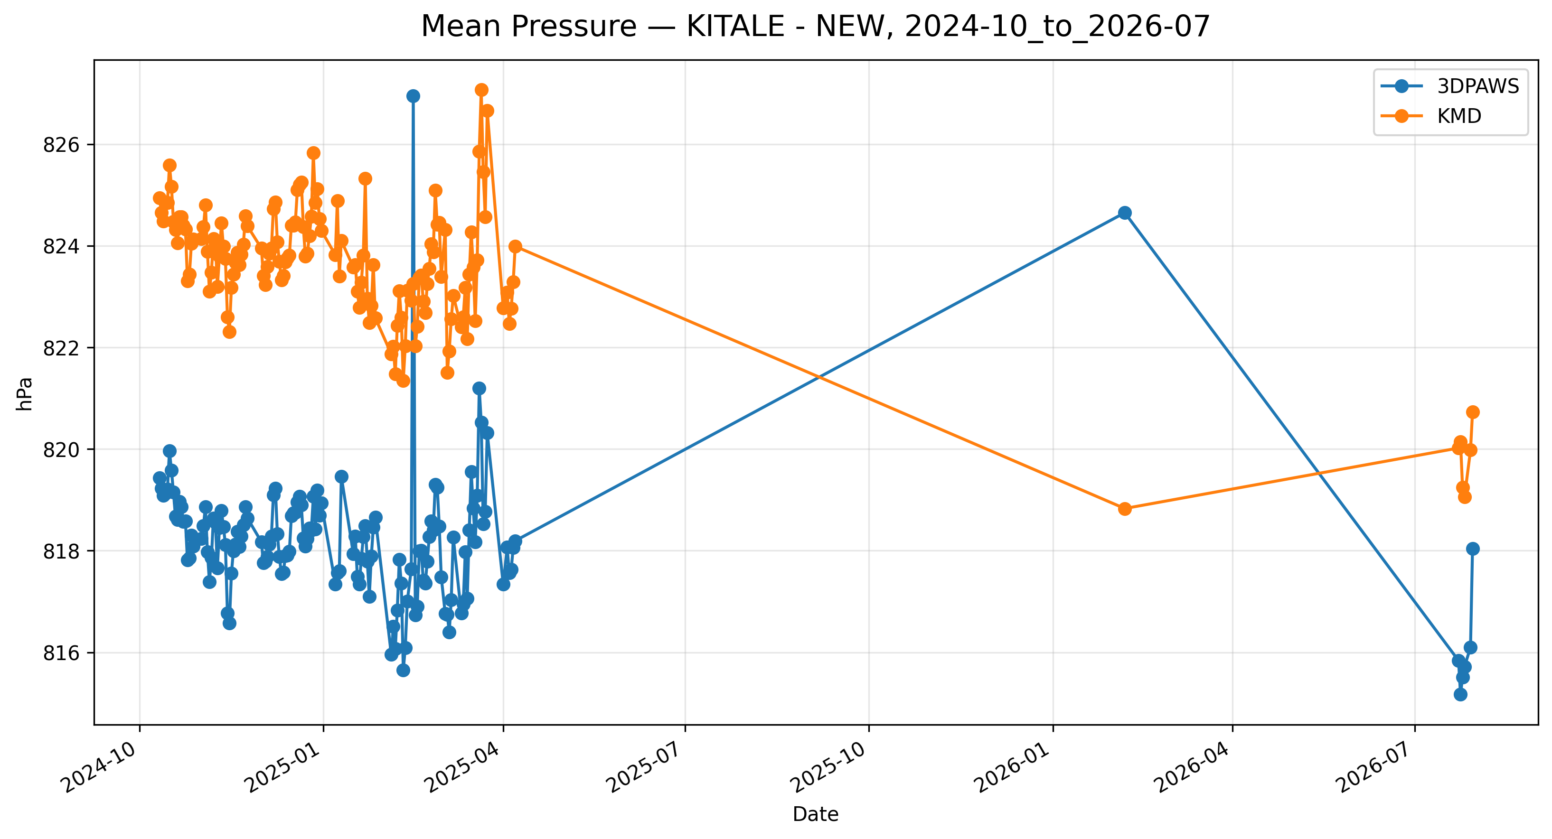
Figure 7.18: Time-series comparison of daily mean pressure observations between 3DPAWS and KMD at KITALE - NEW for 2024-10_to_2026-07.

7.7 Rainfall Results

Daily Rainfall (Rain Gauge 1)
Data status: AVAILABLE | Paired observations: 166 | Comparison missing: 492
Descriptive statistics
Statistic | 3DPAWS | KMD
Observations | 166 | 166
Mean | 86.996 | 3.934
Median | 0.000 | 0.000
Minimum | 0.000 | 0.000
Maximum | 5830.000 | 105.200
Standard Deviation | 557.490 | 11.332
Variance | 310795.239 | 128.421
Validation statistics
Metric | Value
Bias | 83.062 mm
Mean Absolute Error (MAE) | 88.542 mm
Root Mean Square Error (RMSE) | 561.881 mm
Correlation coefficient (r) | 0.019
Coefficient of determination (R²) | 0.000
Performance assessment: Below Threshold
WMO requirement: 244
Criterion | Value
Goal | 0.500 mm
Breakthrough | 2.000 mm
Threshold | 5.000 mm
Interpretation: The paired observations show very weak linear agreement between 3DPAWS and KMD measurements (r = 0.019). The coefficient of determination was R² = 0.000. The mean bias was 83.062 mm, indicating that the 3DPAWS observations were generally higher than the KMD observations. The mean absolute error was 88.542 mm. The root mean square error was 561.881 mm. Under the implemented performance assessment criteria, the parameter was classified as Below Threshold. Rainfall comparison should consider the event-based nature of precipitation and possible spatial variability between gauges.
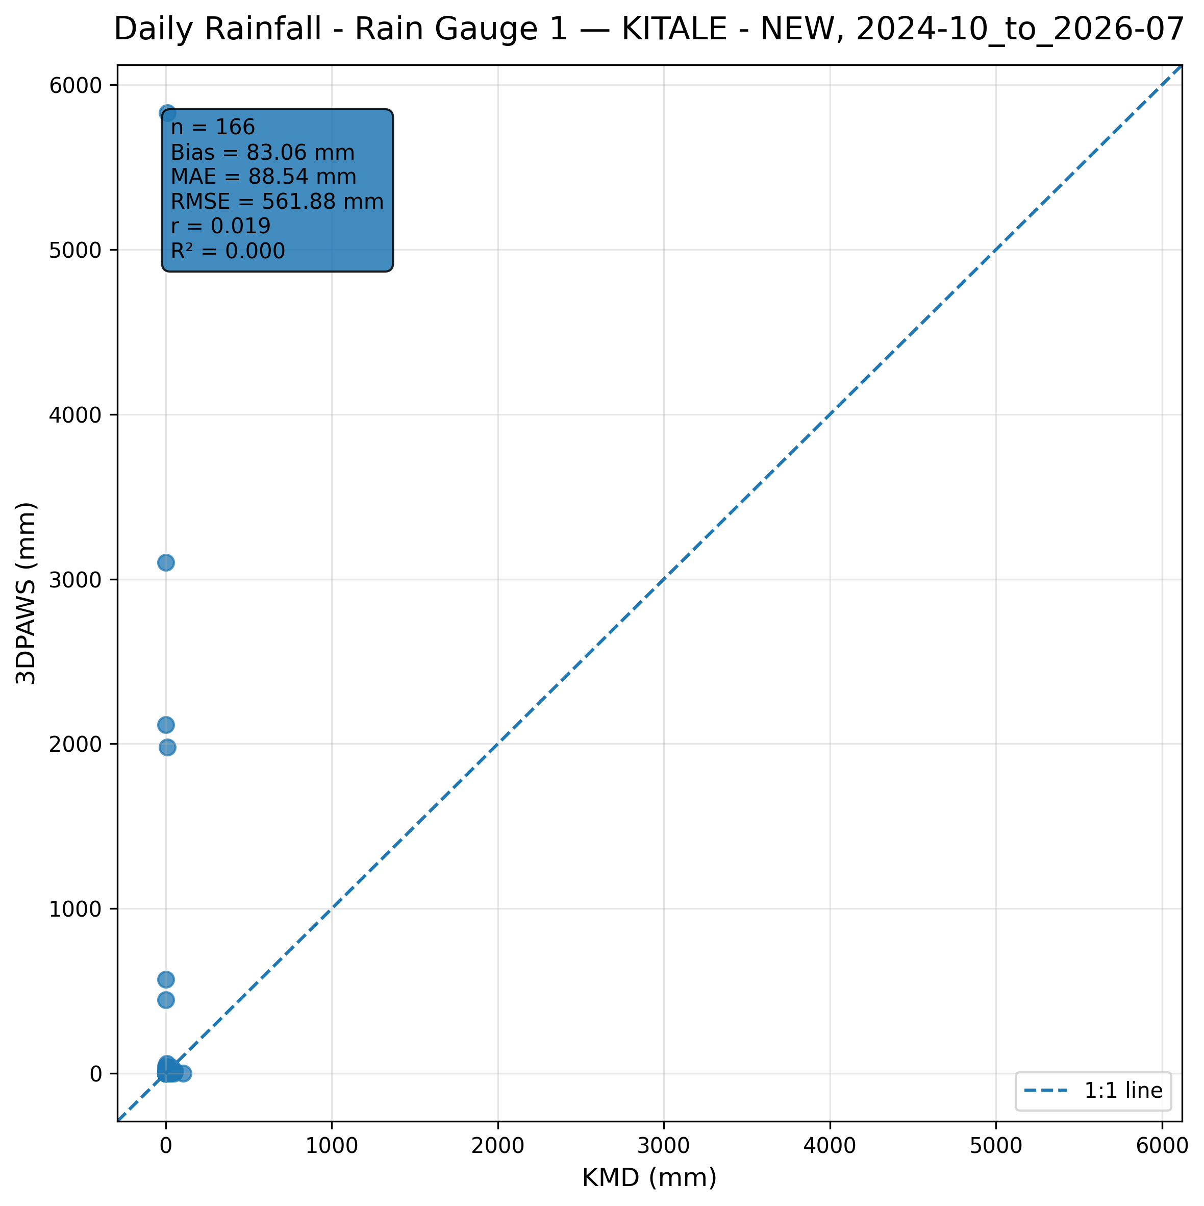
Figure 7.19: Scatter comparison of daily rainfall (rain gauge 1) observations between 3DPAWS and KMD at KITALE - NEW for 2024-10_to_2026-07.
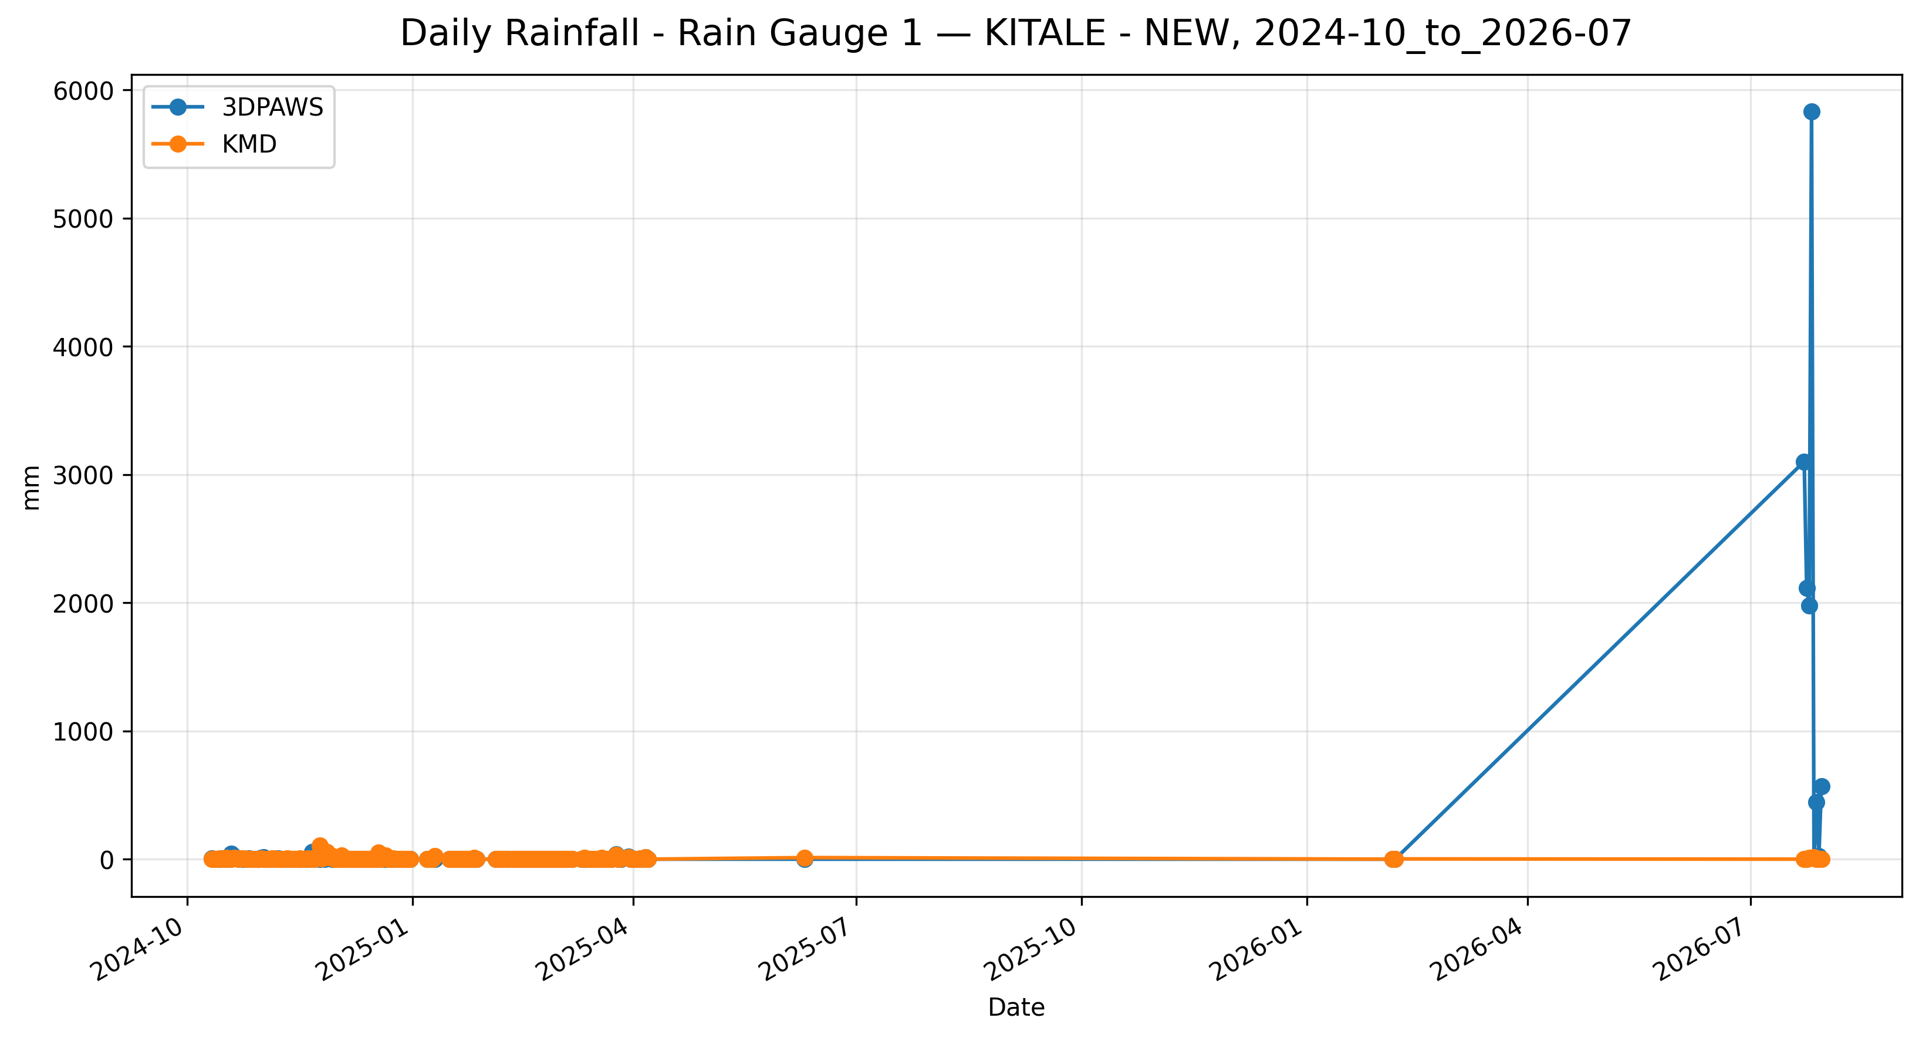
Figure 7.20: Time-series comparison of daily daily rainfall (rain gauge 1) observations between 3DPAWS and KMD at KITALE - NEW for 2024-10_to_2026-07.

Daily Rainfall (Rain Gauge 2)
Data status: AVAILABLE | Paired observations: 166 | Comparison missing: 492
Descriptive statistics
Statistic | 3DPAWS | KMD
Observations | 166 | 166
Mean | 2.180 | 3.934
Median | 0.000 | 0.000
Minimum | 0.000 | 0.000
Maximum | 56.600 | 105.200
Standard Deviation | 6.746 | 11.332
Variance | 45.507 | 128.421
Validation statistics
Metric | Value
Bias | -1.754 mm
Mean Absolute Error (MAE) | 4.166 mm
Root Mean Square Error (RMSE) | 12.425 mm
Correlation coefficient (r) | 0.142
Coefficient of determination (R²) | 0.020
Performance assessment: Below Threshold
WMO requirement: 244
Criterion | Value
Goal | 0.500 mm
Breakthrough | 2.000 mm
Threshold | 5.000 mm
Interpretation: The paired observations show very weak linear agreement between 3DPAWS and KMD measurements (r = 0.142). The coefficient of determination was R² = 0.020. The mean bias was -1.754 mm, indicating that the 3DPAWS observations were generally lower than the KMD observations. The mean absolute error was 4.166 mm. The root mean square error was 12.425 mm. Under the implemented performance assessment criteria, the parameter was classified as Below Threshold. Rainfall comparison should consider the event-based nature of precipitation and possible spatial variability between gauges.
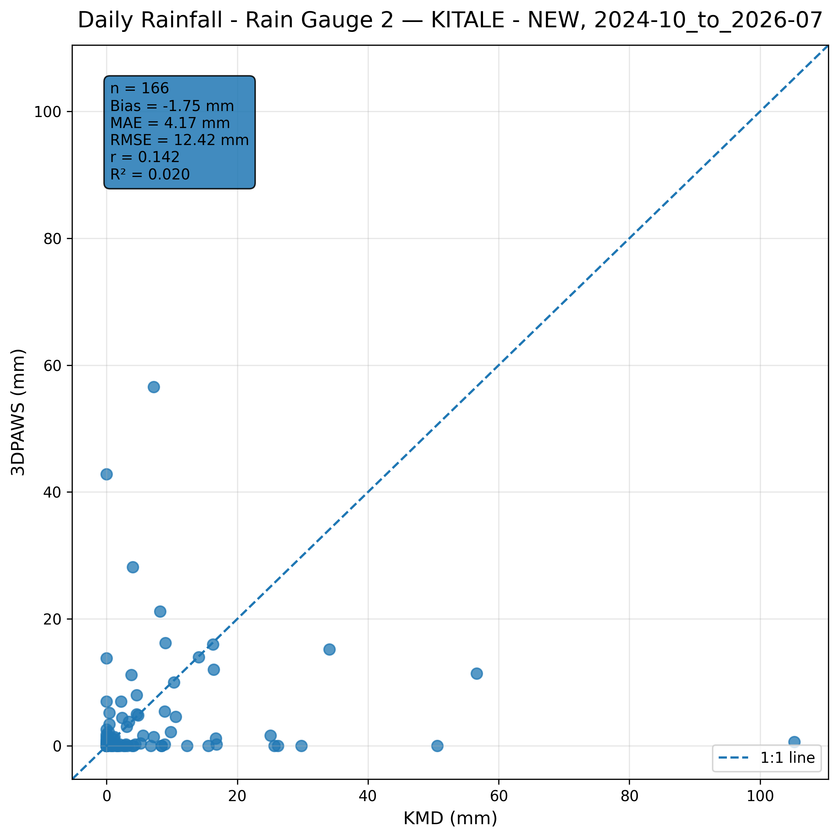
Figure 7.21: Scatter comparison of daily rainfall (rain gauge 2) observations between 3DPAWS and KMD at KITALE - NEW for 2024-10_to_2026-07.
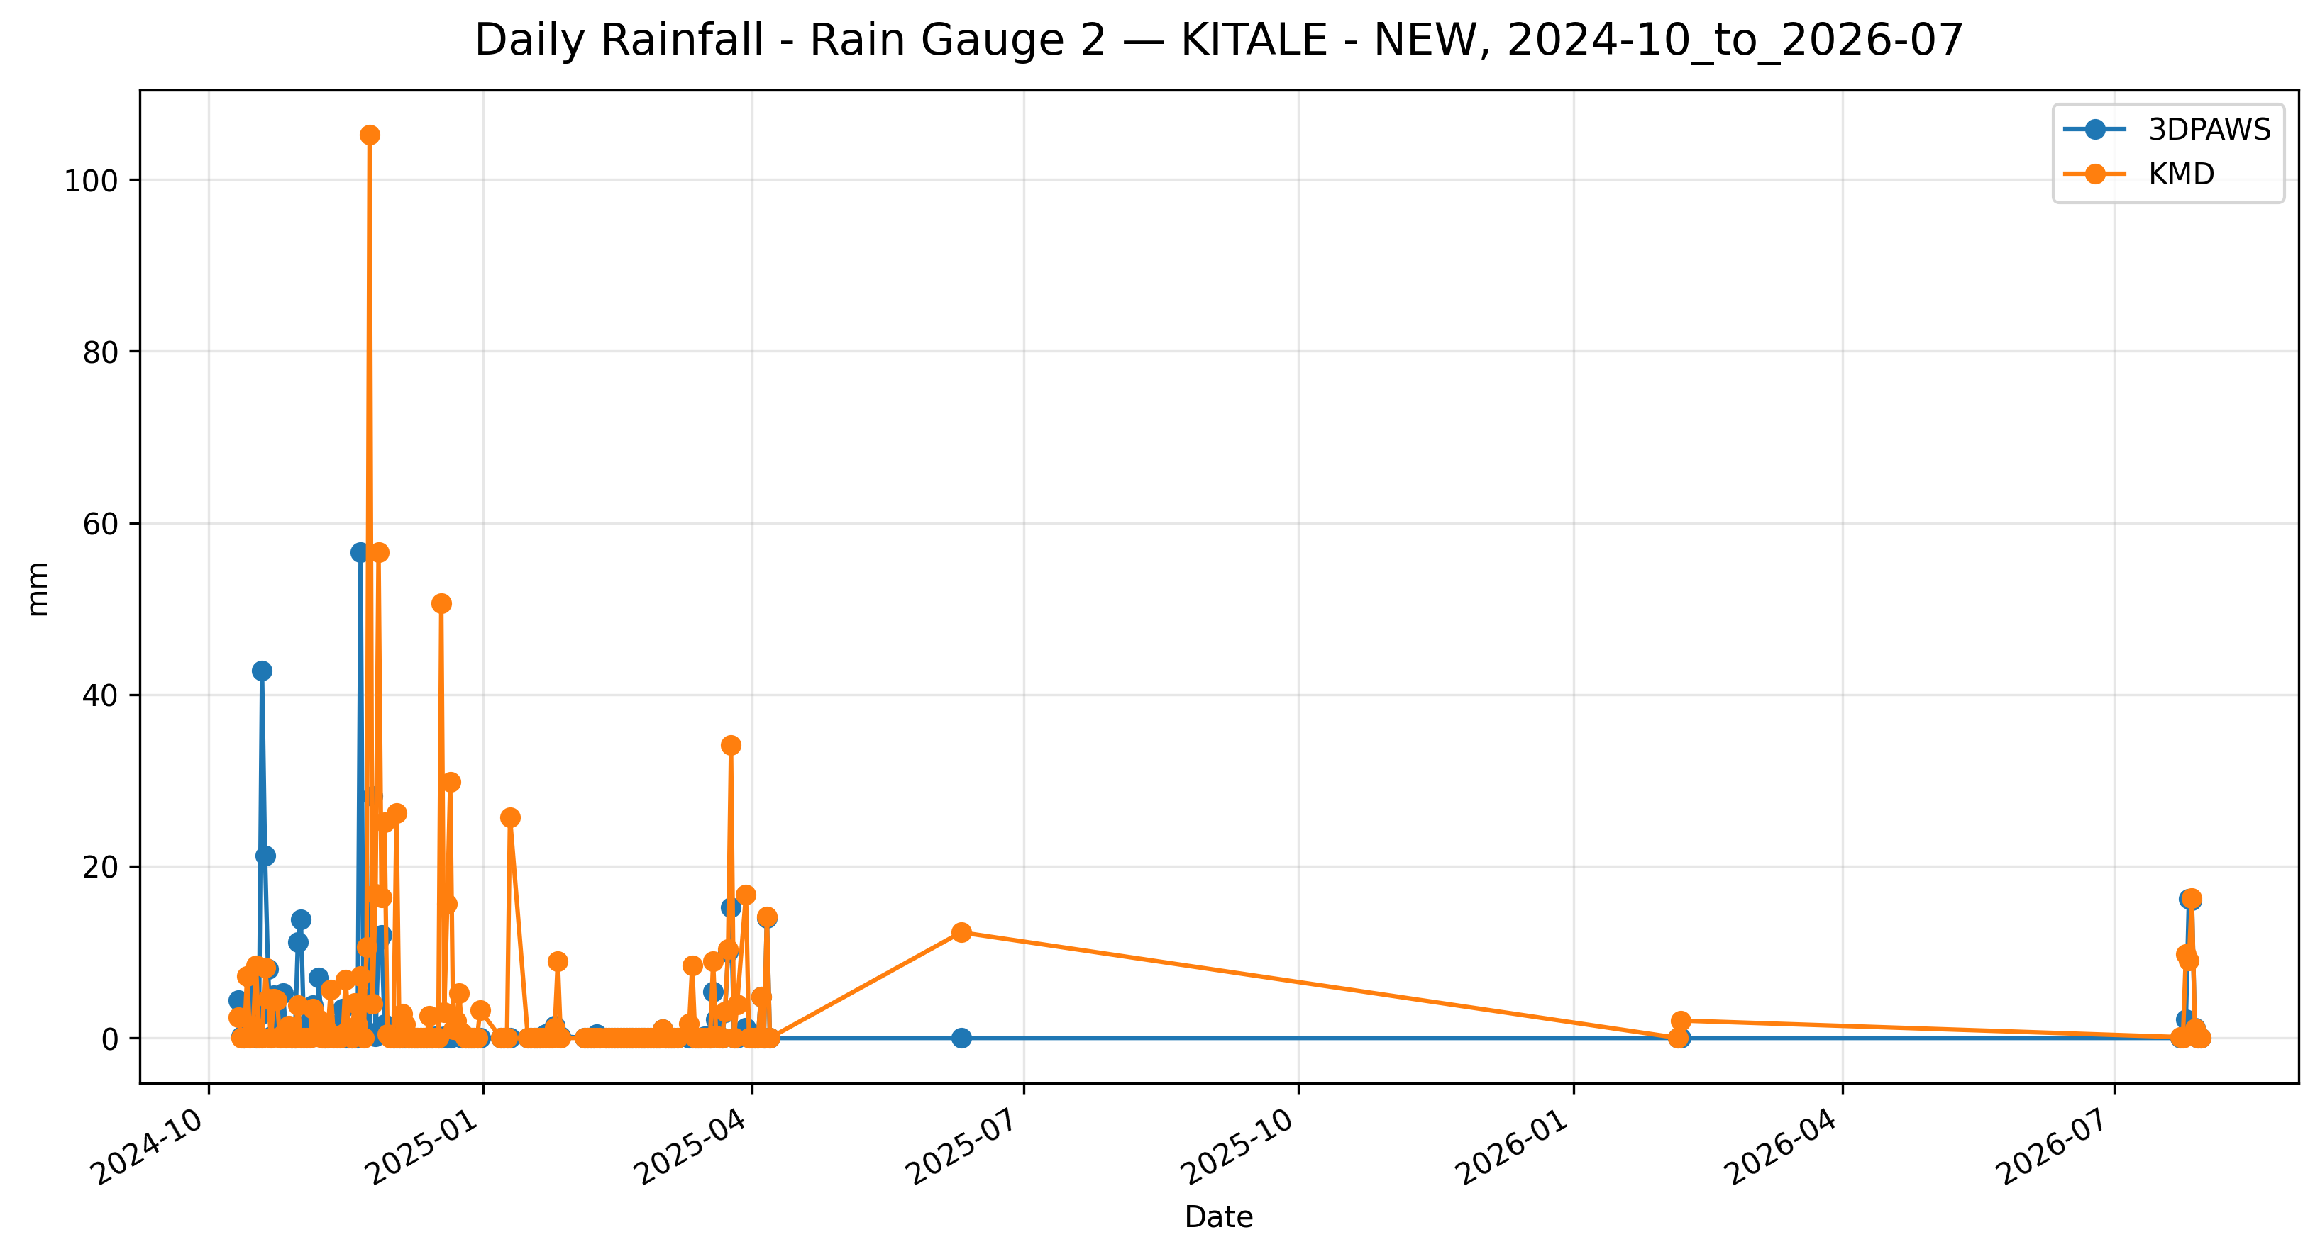
Figure 7.22: Time-series comparison of daily daily rainfall (rain gauge 2) observations between 3DPAWS and KMD at KITALE - NEW for 2024-10_to_2026-07.

7.8 Overall Validation Performance Summary
Category | Parameter | Paired | Bias | MAE | RMSE | r | R² | Assessment | Data Status
Temperature | Maximum Temperature | 152 | 0.352 | 1.214 | 2.282 | 0.616 | 0.380 | Below Threshold | HIGH QUALITY
Temperature | Minimum Temperature | 147 | -0.202 | 1.289 | 2.369 | 0.512 | 0.262 | Below Threshold | HIGH QUALITY
Temperature | Mean Temperature | 143 | -0.937 | 1.445 | 2.085 | 0.379 | 0.143 | Below Threshold | HIGH QUALITY
Humidity | Maximum Relative Humidity | 146 | 25.293 | 26.398 | 28.177 | 0.546 | 0.298 | Below Threshold | HIGH QUALITY
Humidity | Minimum Relative Humidity | 146 | -25.466 | 25.995 | 27.053 | 0.783 | 0.614 | Below Threshold | HIGH QUALITY
Humidity | Mean Relative Humidity | 146 | 2.655 | 6.206 | 8.701 | 0.833 | 0.694 | Below Threshold | HIGH QUALITY
Pressure | Maximum Pressure | 146 | 4.851 | 9.449 | 18.280 | 0.132 | 0.017 | Below Threshold | HIGH QUALITY
Pressure | Minimum Pressure | 146 | -7.841 | 7.921 | 7.954 | 0.570 | 0.324 | Below Threshold | HIGH QUALITY
Pressure | Mean Pressure | 146 | -5.395 | 5.526 | 5.561 | 0.481 | 0.231 | Below Threshold | HIGH QUALITY
Rainfall | Daily Rainfall (Rain Gauge 1) | 166 | 83.062 | 88.542 | 561.881 | 0.019 | 0.000 | Below Threshold | AVAILABLE
Rainfall | Daily Rainfall (Rain Gauge 2) | 166 | -1.754 | 4.166 | 12.425 | 0.142 | 0.020 | Below Threshold | AVAILABLE
The summary table presents the statistical performance of the 3D-PAWS observations against the KMD reference dataset. Bias indicates the average systematic difference between the two systems, while MAE and RMSE describe the magnitude of observation differences. The correlation coefficient (r) and coefficient of determination (R²) describe the agreement in observed temporal variability.
Performance classifications should be interpreted together with the statistical indicators and environmental characteristics of each parameter. Parameters classified below the implemented threshold criteria may still demonstrate useful operational capability, particularly where strong temporal agreement is observed.

7.9 Overall Station Performance Assessment
The overall performance assessment for KITALE - NEW was derived from the statistical comparison of individual meteorological parameters between the 3D-PAWS station and the KMD reference station. The assessment considers temporal agreement, magnitude of differences, observation coverage, and the parameter-specific performance criteria implemented in the validation toolkit.
The assessment is presented by meteorological parameter group. Within each group, the results are interpreted using correlation, error statistics, bias, and performance classification rather than relying on a single statistical indicator.

Temperature
Maximum Temperature demonstrated the strongest temporal agreement within the temperature parameter group, with r = 0.616.
Mean Temperature recorded the lowest RMSE within the group (2.085 °C).
Minimum Temperature showed the smallest absolute bias within the group, with a bias of -0.202 °C.
Temperature observations demonstrated useful agreement with the KMD reference observations. Differences in correlation and error magnitude indicate that individual temperature statistics should be considered separately when assessing station performance.
Performance classification: Below Threshold

Humidity
Mean Relative Humidity demonstrated the strongest temporal agreement within the humidity parameter group, with r = 0.833.
Mean Relative Humidity recorded the lowest RMSE within the group (8.701 %).
Mean Relative Humidity showed the smallest absolute bias within the group, with a bias of 2.655 %.
Relative humidity observations demonstrated temporal agreement with the KMD reference observations. Differences in absolute values should be considered when interpreting measurement agreement and performance classification. Further investigation may consider sensor calibration, exposure, and local environmental conditions.
Performance classification: Below Threshold

Pressure
Minimum Pressure demonstrated the strongest temporal agreement within the pressure parameter group, with r = 0.570.
Mean Pressure recorded the lowest RMSE within the group (5.561 hPa).
Maximum Pressure showed the smallest absolute bias within the group, with a bias of 4.851 hPa.
Atmospheric pressure observations showed differences in temporal agreement among the evaluated pressure statistics. Differences may be associated with elevation correction, pressure-reduction procedures, sensor response characteristics, and station exposure.
Performance classification: Below Threshold

Rainfall
Daily Rainfall (Rain Gauge 2) demonstrated the strongest temporal agreement within the rainfall parameter group, with r = 0.142.
Daily Rainfall (Rain Gauge 2) recorded the lowest RMSE within the group (12.425 mm).
Daily Rainfall (Rain Gauge 2) showed the smallest absolute bias within the group, with a bias of -1.754 mm.
Rainfall observations demonstrated the capability of the 3D-PAWS rain gauge system to capture rainfall occurrence and event variability. Differences in rainfall magnitude should be interpreted in relation to precipitation spatial variability and differences between the 3D-PAWS and KMD rain-gauge systems.
Performance classification: Below Threshold

7.10 Key Findings
The validation assessment conducted at KITALE - NEW demonstrated that the 3D-PAWS system reproduced meaningful temporal variability in several meteorological parameters when compared with the KMD reference observations.
- Temperature performance was strongest for Maximum Temperature, which recorded the highest temperature correlation at r = 0.616. Mean Temperature also recorded the lowest temperature RMSE of 2.085 °C. The smallest absolute temperature bias was observed for Minimum Temperature, at -0.202 °C.
- Relative humidity showed the strongest temporal agreement for Mean Relative Humidity, with r = 0.833 and R² = 0.694. The parameter assessments were Below Threshold under the implemented criteria. The results therefore indicate the degree of temporal reproduction achieved by the 3D-PAWS observations, while absolute differences should be considered when interpreting compliance with the applicable performance criteria.
- Atmospheric pressure showed the weakest temporal agreement among the evaluated parameter groups. The lowest pressure correlation was observed for Maximum Pressure, at r = 0.132. Maximum Pressure showed the closest agreement in absolute magnitude, with a bias of 4.851 hPa and an MAE of 9.449 hPa. These results highlight pressure reduction and elevation-correction procedures as areas requiring further evaluation.
- Rainfall observations demonstrated temporal agreement with the KMD reference observations, with Daily Rainfall (Rain Gauge 2) recording the highest rainfall correlation at r = 0.142. Differences in rainfall magnitude should nevertheless be interpreted considering precipitation spatial variability and differences between the 3D-PAWS and KMD rain-gauge systems.
- Under the performance criteria implemented in the validation toolkit, the assessment distribution was Below Threshold: 11. These classifications describe compliance with the implemented statistical criteria and should not be interpreted independently of temporal agreement, error magnitude, observation coverage, and the intended operational use of each parameter.
- Parameter-level paired-observation coverage ranged from 21.7% for Mean Temperature to 25.2% for Daily Rainfall (Rain Gauge 1). These coverage differences should be considered when interpreting parameter-level statistical results.
Overall, the KITALE - NEW validation results demonstrate that 3D-PAWS was able to reproduce meaningful temporal variability across several meteorological parameters, particularly relative humidity, rainfall, and temperature. However, strong temporal agreement did not consistently translate into compliance with the implemented accuracy thresholds, particularly for relative humidity and atmospheric pressure. These findings indicate the potential of 3D-PAWS as a cost-effective approach for meteorological observation network densification, while highlighting the need for continued sensor calibration, refinement of pressure-reduction and elevation-correction procedures, further development of quality-control procedures, and evaluation across additional stations and environmental conditions before wider operational deployment.

